Data Analysis
1. Importing the Data into SAS
The data for this project is the detailed listings file (listings.csv.gz) for Nairobi, Kenya, downloaded from Inside Airbnb. The data was collected on 14 September 2026. After extracting the file with 7-Zip, I uploaded listings.csv to SAS OnDemand for Academics (SAS Studio).
Before importing, I checked the file and found that the host_about column contained line breaks inside the text for some listings. PROC IMPORT reads every line break as the start of a new row, so these listings would have been split into several incorrect rows. To prevent this, I used a DATA step to replace the line breaks inside quoted text with spaces and saved the result as a new file, listings_clean.csv. I then imported this cleaned file with PROC IMPORT, using GUESSINGROWS=MAX so that SAS checked every row before deciding each variable’s type and length. The data was saved as a permanent SAS data set, AIRBNB.LISTINGS.
PROC CONTENTS shows that the data set has 22,669 observations (listings) and 90 variables, which matches the number of listings in the original file. The first five rows (PROC PRINT) show that the values were read correctly.
One important point from PROC CONTENTS is that price was imported as a character variable (length 15), because the values include a dollar sign and commas (for example, “$7,640.00”). Price must be converted to a numeric variable before it can be analyzed or used as the dependent variable. This is done in the next step. The prices are in Kenyan Shillings (KES), the local currency, even though they display a “$” sign.
Figure 1: PROC CONTENTS – data set summary (Observations 22,669, Variables 90)
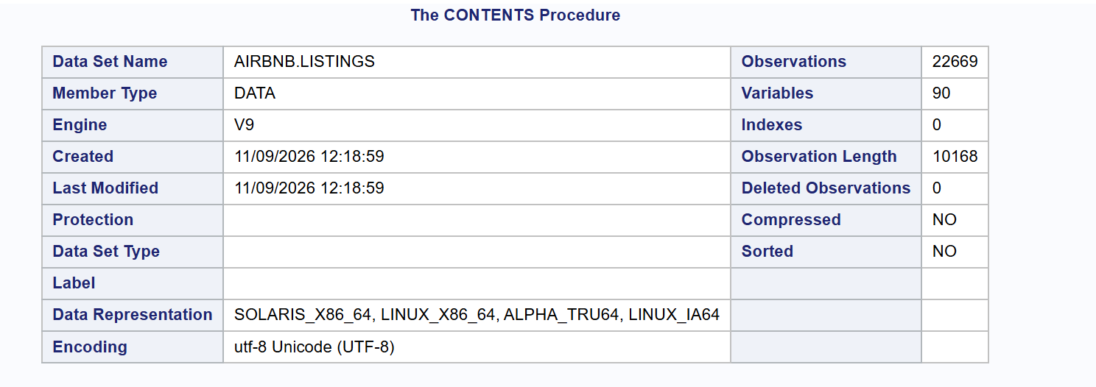
Figure 2: PROC PRINT – first five listings
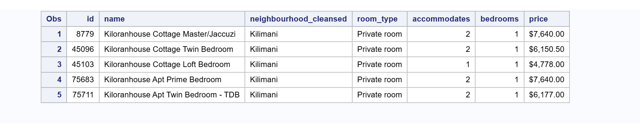
2. Fitting a Linear Regression Model with Price as the Dependent Variable
a. Investigating the Dependent Variable
i. Missing and Nonsensical Values
Price was imported as text (for example, “$7,640.00”), so I first converted it to a numeric variable by removing the dollar sign and commas. The converted data was saved as a new data set, AIRBNB.NAIROBI, so that the original imported data stays unchanged. Price is the nightly price in Kenyan Shillings (KES).
Missing values.
PROC MEANS (Figure 3) and the Missing Values table from PROC UNIVARIATE (Figure 5) show that 386 of the 22,669 listings have no price. That is 1.70% of all listings, leaving 22,283 listings with a price. Because price is the dependent variable, these listings cannot be used to build or test a model, and filling them in with an estimate would mean making up the value we are trying to predict. These 386 listings will therefore be removed from the data.
Zero or negative values. A nightly price of zero or less would not make sense. The count in Figure 4 shows that no listing has a price of zero or less. The lowest price is KES 878.90.
Range and unusual values. PROC UNIVARIATE (Figure 5) shows that price ranges from KES 878.90 to KES 4,174,252, a range of KES 4,173,373. Most listings fall within a much narrower range. The median is KES 5,827, half of all listings cost between KES 3,625 (Q1) and KES 9,064 (Q3), and 99% of listings cost KES 41,436 or less. The Extreme Observations table, however, shows several listings priced far above this, including prices above KES 1,000,000 per night and a highest value of KES 4,174,252. That is more than 700 times the median price. Prices like these are very unlikely for one night in a Nairobi Airbnb listing and are most likely entry errors or placeholder prices set by hosts. These extreme values are examined as outliers in the next section.
The mean (KES 8,971) is also much higher than the median (KES 5,827), and the standard deviation (KES 43,339) is almost five times the mean. Both show that a small number of very high prices are pulling the average up. This is examined further in Step iii, which looks at the shape of the distribution.
Figure 3: PROC MEANS – missing values and range of price
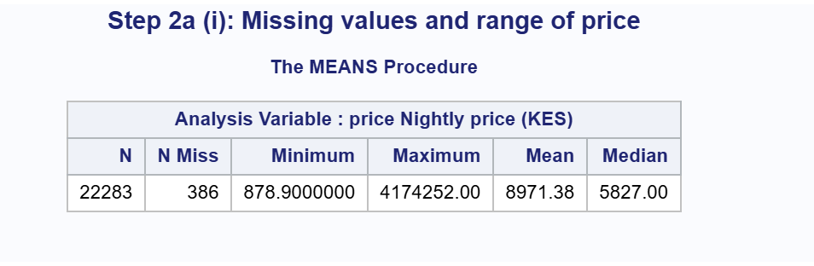
Figure 4: Count of listings with a price of zero or less

Figure 5: PROC UNIVARIATE – Moments, Basic Statistical Measures, Quantiles, Extreme Observations and Missing Values
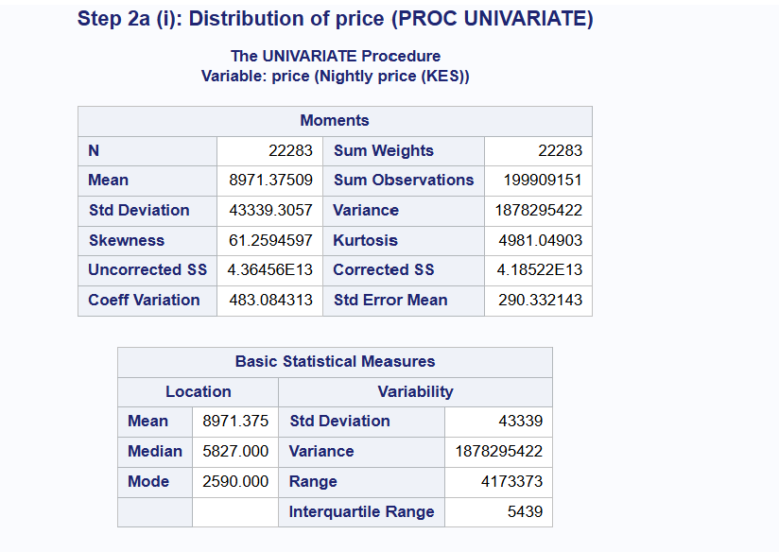
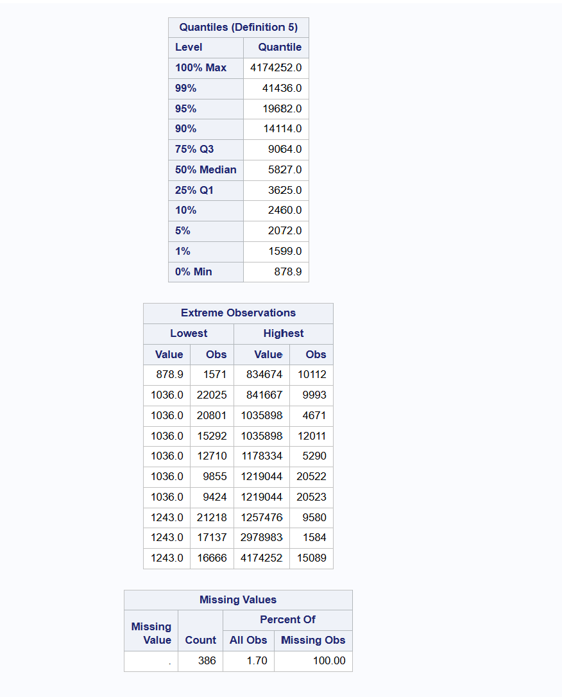

ii. Outliers
The Extreme Observations table in Step i showed some prices that were far higher than the rest of the data. To decide which values are outliers, I used the 1.5 × IQR rule: a value is an outlier if it falls more than 1.5 times the interquartile range (IQR) below the first quartile (Q1) or above the third quartile (Q3).
Price is very strongly right-skewed. Applied to the raw prices, the rule would flag many normal listings as outliers, such as larger homes that simply cost more. For this reason, I applied the rule to the natural log of price, which reduces the effect of the skew, and then converted the cut-offs back to Kenyan Shillings. This matches the approach in Program 2.7, which works with the log of the dependent variable.
The box plot of log(price) (Figure 6) shows the problem clearly. Most listings fall within a narrow range, but there is a long line of points above the upper whisker and one point below the lower whisker.
For log(price), Q1 = 8.196, Q3 = 9.112 and IQR = 0.916 (Figure 7). This gives:
- Lower cut-off: 8.196 − 1.5 × 0.916 = 6.821, which is KES 916.83
- Upper cut-off: 9.112 + 1.5 × 0.916 = 10.487, which is KES 35,837.50
Using these cut-offs, 295 listings (1.3% of listings with a price) were identified as outliers: 1 low outlier and 294 high outliers (Figure 8). The low outlier is the listing priced at KES 878.90.
The ten highest-priced outliers (Figure 9) show that many of these prices are not realistic. For example:
- A one-bedroom apartment for two guests in Westlands is priced at KES 4,174,252 per night.
- A listing named “Suites” is recorded as a private room with 50 bedrooms for only 2 guests, priced at KES 1,257,476.
- One listing is named “null and Void”, which suggests it is not a real, active listing.
These listings are small, ordinary homes with prices hundreds of times higher than the median of KES 5,827. This suggests the prices are entry errors or placeholder prices rather than real nightly rates. Keeping them would pull the regression line toward a few wrong values and give a poor model for normal listings.
I therefore removed the 386 listings with a missing price and the 295 outliers, and saved the remaining data as AIRBNB.NAIROBI_CLEAN. This data set has 21,988 listings (97.0% of the original 22,669). As shown in Figure 10, price now ranges from KES 1,036 to KES 35,797, with no missing values. The mean fell from KES 8,971 to KES 7,105 and is now much closer to the median of KES 5,827. That shows the extreme values were having a large effect on the average.
Figure 6: Box plot of log(price)
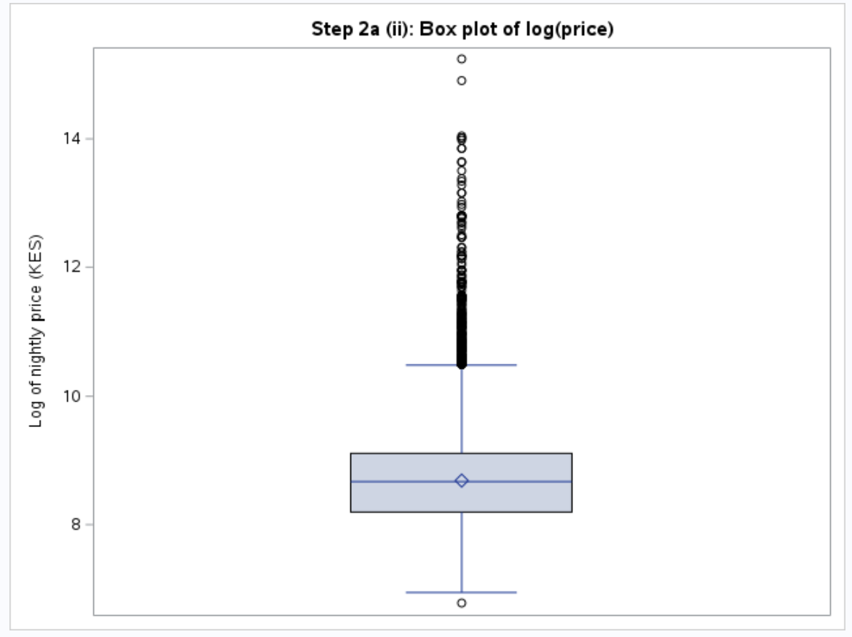
Figure 7: Outlier cut-offs (1.5 × IQR rule on log price)
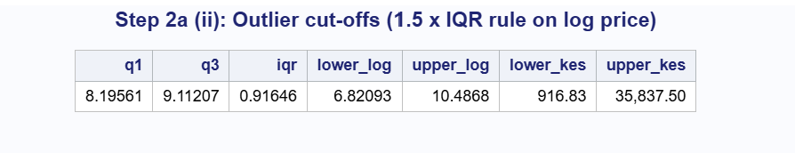
Figure 8: Number of low and high price outliers
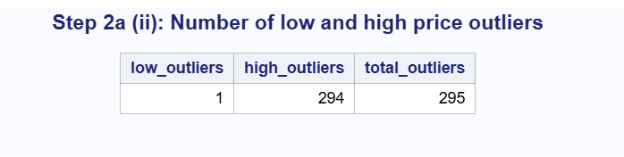
Figure 9: Ten highest-priced outlier listings
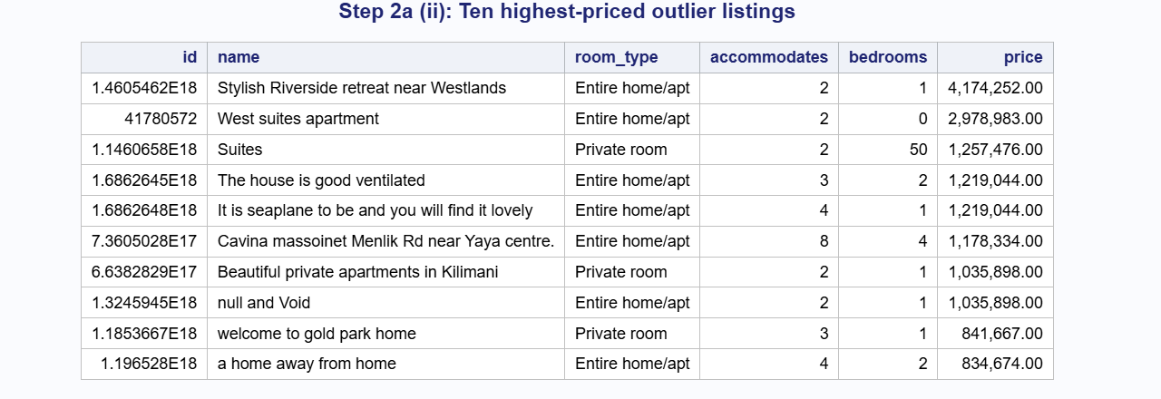
Figure 10: PROC MEANS – price after removing missing values and outliers
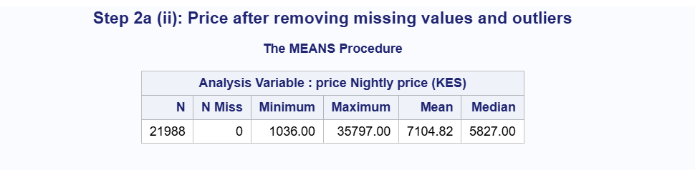

iii. Shape of the Price Distribution
After removing the missing values and outliers, I ran PROC UNIVARIATE again on price in the clean data set (21,988 listings) to check whether price is normally distributed.
Price is still clearly right-skewed:
- The histogram (Figure 11) shows most listings at the lower end, roughly KES 2,000 to 8,000, with a long tail of more expensive listings stretching to the right. The normal curve does not match the shape of the bars.
- The skewness is 2.05 and the kurtosis is 5.34 (Figure 12). A normal distribution has skewness and kurtosis close to 0. A skewness above 1 is usually treated as high.
- The mean (KES 7,105) is higher than the median (KES 5,827). This happens when a long right tail pulls the mean up.
- The normal Q-Q plot (Figure 13) does not follow the straight line. The points curve away from the line at both ends, and the upper end bends sharply upward, which is the pattern of a right-skewed variable.
- All three tests for normality (Kolmogorov-Smirnov D = 0.142, Cramér-von Mises and Anderson-Darling) have p-values below 0.01 (Figure 12), so normality is rejected.
Because linear regression works best when the dependent variable (and therefore the errors) is close to normal, price needs to be transformed.
iv. Choosing a Transformation
Price has a positive (right) skew of 2.05, which falls in the high skew range of the guideline table. The table recommends the natural log transformation for high positive skew, and the square root for moderate skew. To confirm the choice, I created both versions of price and compared them (Figure 14):
Variable | Skewness | Kurtosis
price | 2.052 | 5.338
square root of price | 1.056 | 1.278
natural log of price | 0.203 | −0.361
(Add this in a table)
The square root reduced the skewness by about half, but the variable is still clearly skewed (1.056). The natural log brought the skewness down to 0.203 and the kurtosis to −0.361, both close to 0. A log base 10 transformation would give the same skewness, because it is the natural log multiplied by a constant, so it offers no extra improvement.
The histogram of log(price) (Figure 15) is now roughly bell-shaped, and the mean (8.652) and median (8.670) are almost equal. The Q-Q plot (Figure 16) follows the straight line closely for most of the data. The points flatten only at the very ends, which is expected because the outliers beyond these limits were removed in Step ii. The tests for normality still have p-values below 0.01, but with almost 22,000 listings these tests reject even very small departures from normality. The Kolmogorov-Smirnov statistic fell from 0.142 for price to 0.037 for log(price), which shows a large improvement.
I therefore chose the natural log of price (log_price) as the dependent variable for the models. This is also the transformation used in the textbook (Program 2.7). Because the models predict log(price), predictions can be converted back to Kenyan Shillings with the exponential function, exp(log_price).
Figure 11: Histogram of price (clean data) with normal curve
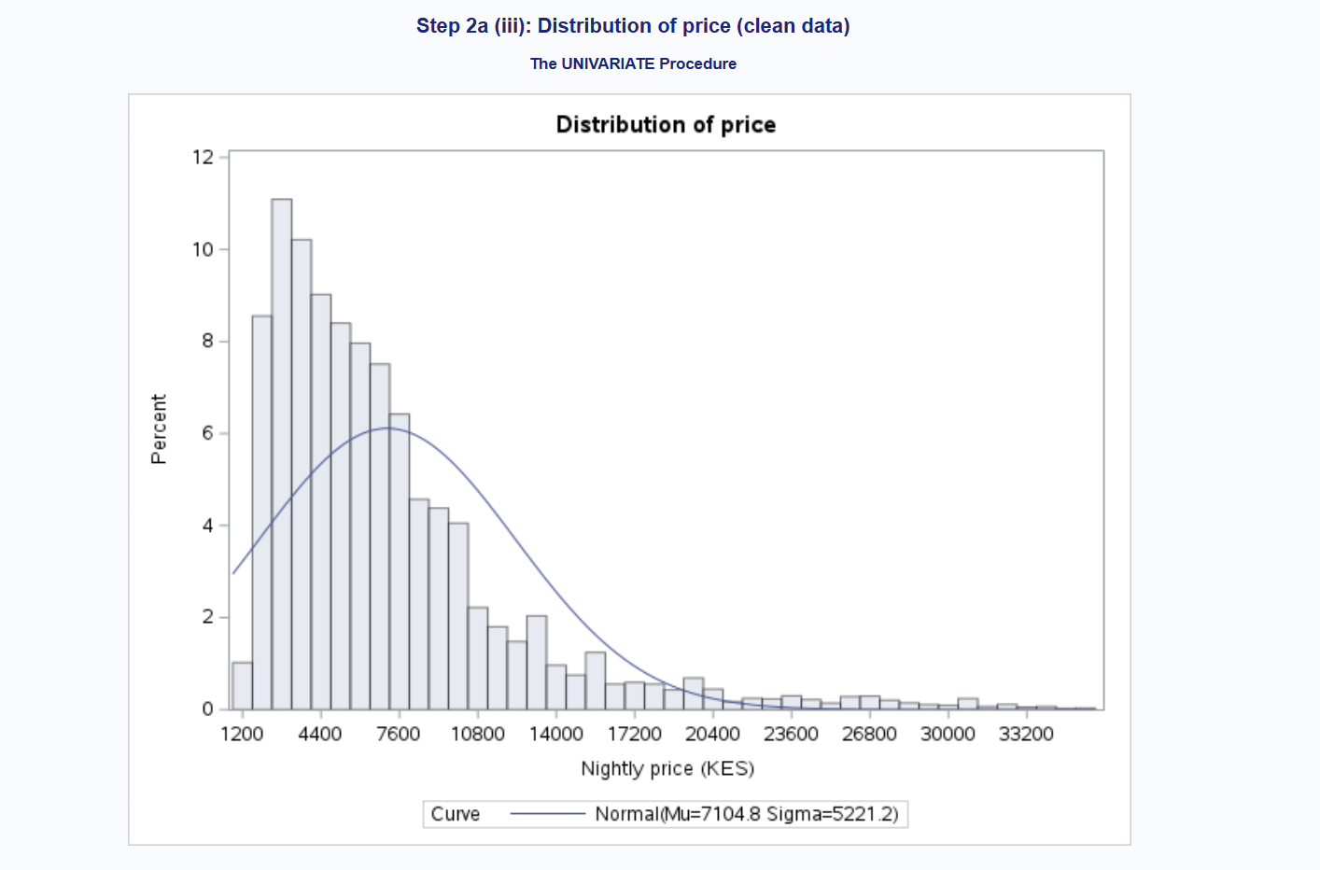
Figure 12: PROC UNIVARIATE – Moments and Tests for Normality for price]
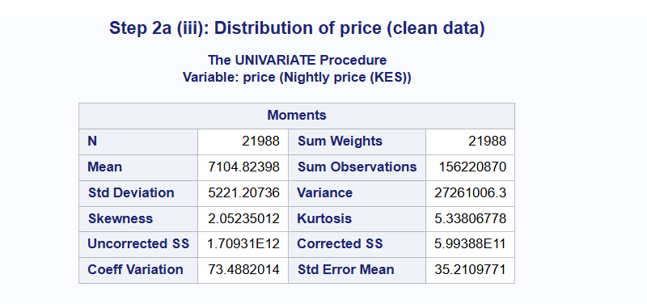
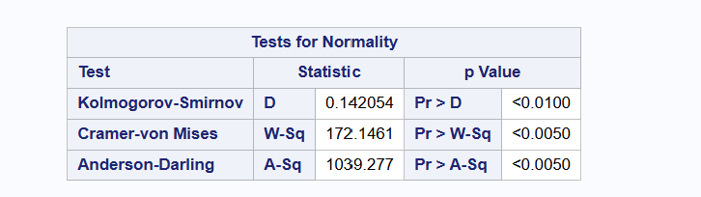
Figure 13: Normal Q-Q plot of price]
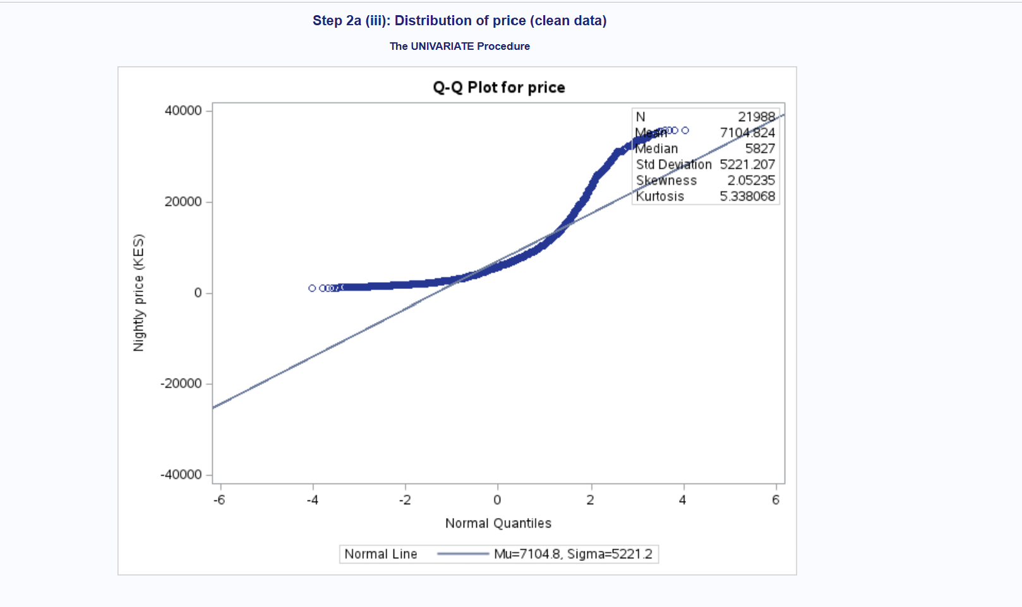
Figure 14: Skewness and kurtosis of price and its transformations
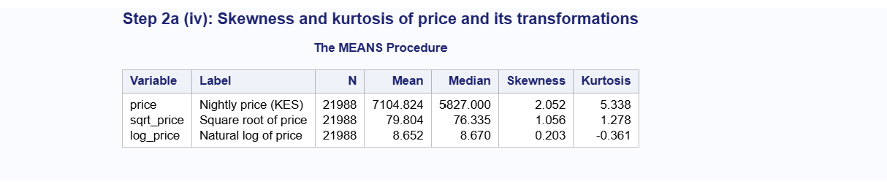
Figure 15: Histogram of log(price) with normal curve
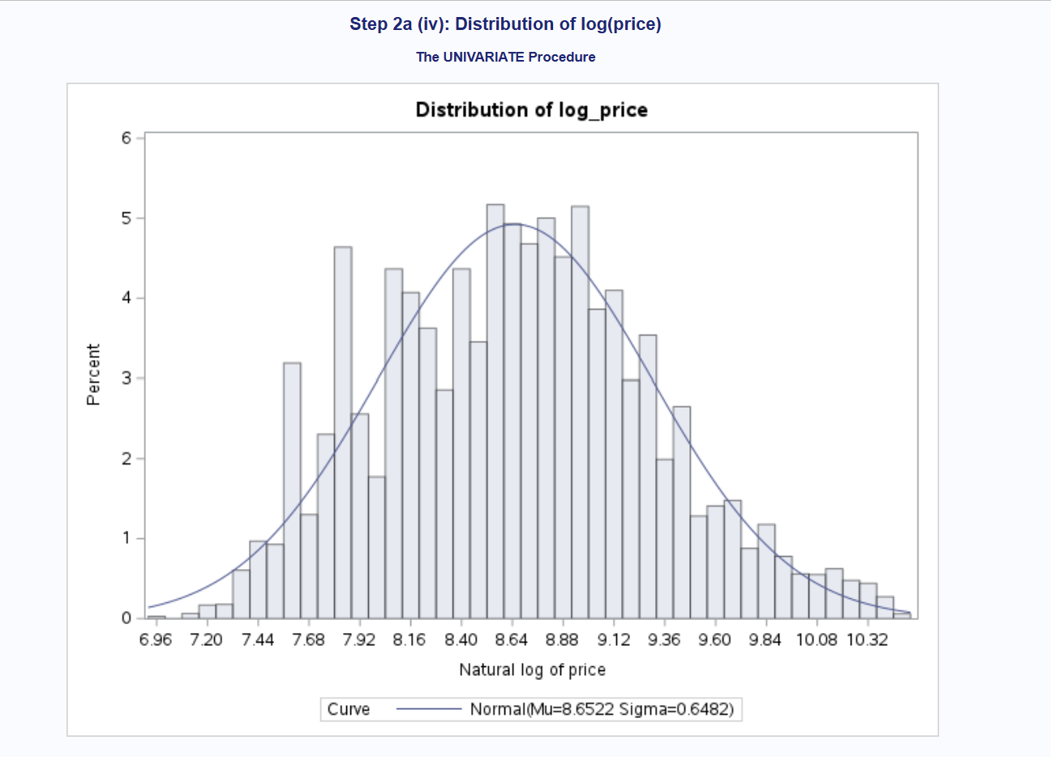

Some bars are taller than those next to them because many hosts set their prices at common round amounts, which makes certain price levels appear more often.
Figure 16: Normal Q-Q plot of log(price)
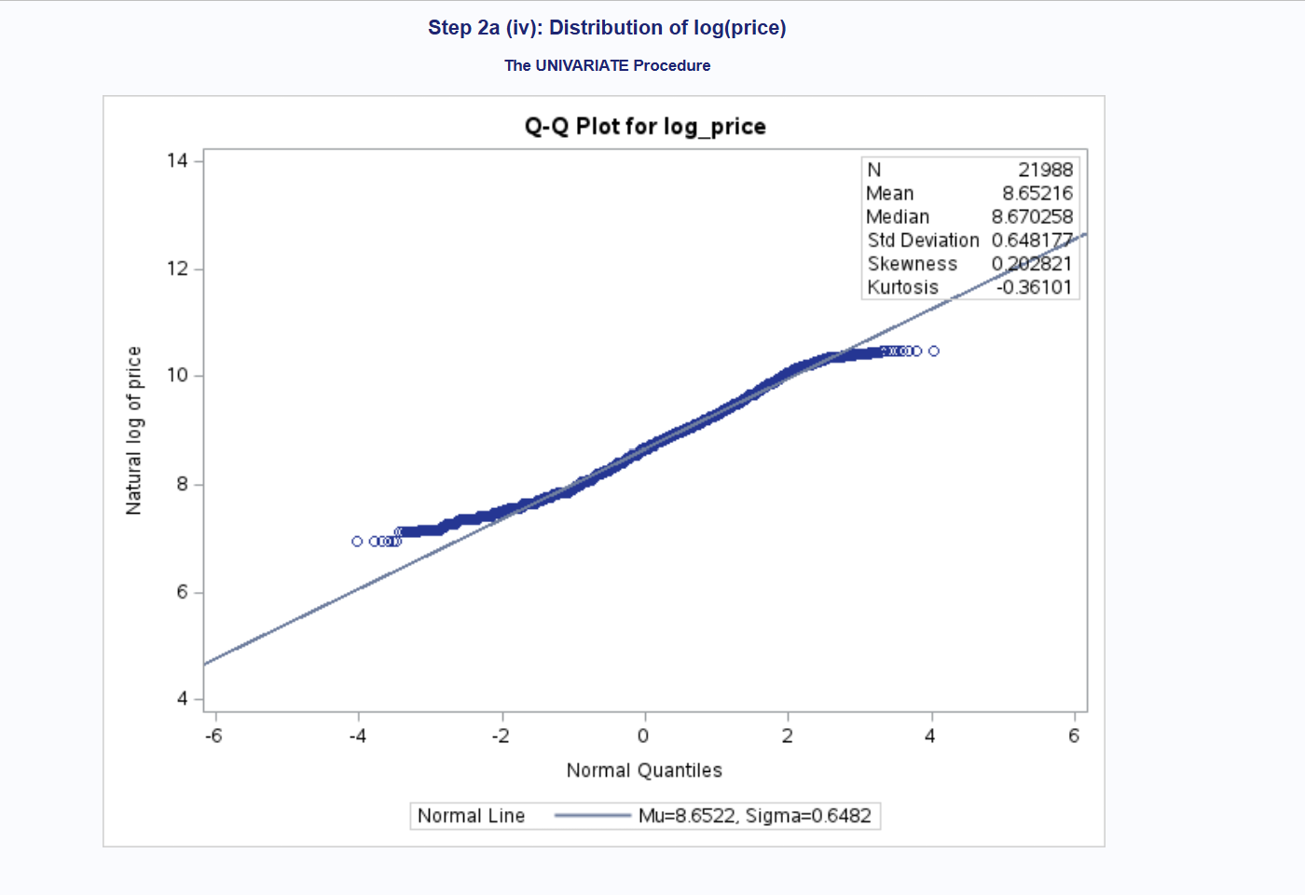

Investigating the Predictors
i. Numeric Variables
1. Multicollinearity
Before checking the numeric predictors, I converted bathrooms_text into numbers, because it is stored as text (for example, “1.5 baths”, “1 shared bath”, “Half-bath”). I created a numeric variable, bathrooms, which takes the number at the start of the text and counts a half-bath as 0.5. I also created a flag, shared_bath (1 = shared bathroom, 0 = private), so that the information about shared bathrooms is not lost.
I then checked for multicollinearity among the 23 numeric predictors from the data dictionary in two ways: a correlation table (following Program 2.9) and Variance Inflation Factors (VIFs) from a regression model (following Program 2.10).
Correlation table. Because a 23 × 23 correlation table is too large to show, the correlations are displayed as a heat map (Figure 17), where dark red means a strong positive correlation. A list of all pairs with a correlation of 0.70 or higher is shown in Figure 18. Three groups of predictors are strongly related:
- Availability: availability_30, availability_60 and availability_90 are almost the same measure. availability_60 and availability_90 have r = 0.979, availability_30 and availability_60 have r = 0.951, and availability_30 and availability_90 have r = 0.899. This makes sense, because the number of free days in the next 60 or 90 days includes the free days in the next 30 days.
- Review scores: the seven review scores are all strongly related to each other, with r between 0.703 and 0.900. Guests who rate a listing highly on one area tend to rate it highly on the others. The overall rating has its strongest link with value (r = 0.900) and accuracy (r = 0.871).
- Size: bedrooms, beds and bathrooms are related (r between 0.702 and 0.799), because larger homes tend to have more of all three.
number_of_reviews_ltm and reviews_per_month (r = 0.789) and number_of_reviews_l30d and reviews_per_month (r = 0.728) are also related, because they all measure how often a listing is reviewed.
VIF check. A VIF above 10 is commonly used as a sign of serious multicollinearity, and a VIF above 5 as a sign of moderate multicollinearity. With all 23 numeric predictors in the model (Figure 19):
- availability_60 (VIF = 54.58), availability_90 (VIF = 28.62) and availability_30 (VIF = 12.41) are all above 10.
- review_scores_rating (VIF = 7.21), review_scores_value (VIF = 6.94) and review_scores_accuracy (VIF = 5.58) are above 5.
- All other predictors have VIFs below 4, including bedrooms (3.43), beds (2.66) and bathrooms (2.76).
The multicollinearity among the availability and review score variables also shows in the coefficients. For example, availability_60 has a positive coefficient while availability_30 and availability_90 have negative ones, even though all three measure the same thing. This is a typical result of multicollinearity: the model cannot separate the effects of variables that move together, so their coefficients become unstable and hard to interpret.
How the issue was addressed.
I removed the variables that repeat information:
- availability_60 and availability_90 were removed and availability_30 was kept. availability_30 carries most of the same information and reflects near-term demand for the listing. availability_365 was kept because its correlation with the others is only moderate (r between 0.43 and 0.51).
- The six review sub-scores (accuracy, cleanliness, check-in, communication, location and value) were removed and review_scores_rating was kept. The overall rating is strongly related to all six, so it summarises the guest’s overall view of the listing.
- bedrooms, beds and bathrooms were all kept, because their VIFs are below 4, which is acceptable. Each also gives some different information about the size of the listing.
After these changes, I fitted the model again (Figure 20). All VIFs are now below 4. The highest are reviews_per_month (3.76), bedrooms (3.43) and number_of_reviews_ltm (3.16). The VIF of availability_30 fell from 12.41 to 1.34, and the VIF of review_scores_rating fell from 7.21 to 1.04. Multicollinearity is no longer a concern for the remaining 15 numeric predictors.
Note that both VIF models used only about 9,100 of the 21,988 listings (Figures 19 and 20). This is because about 58% of listings have no review scores, and SAS removes any listing with a missing value from the regression. The missing values are dealt with in Step 3 below.
Figure 17: Correlation heat map of numeric predictors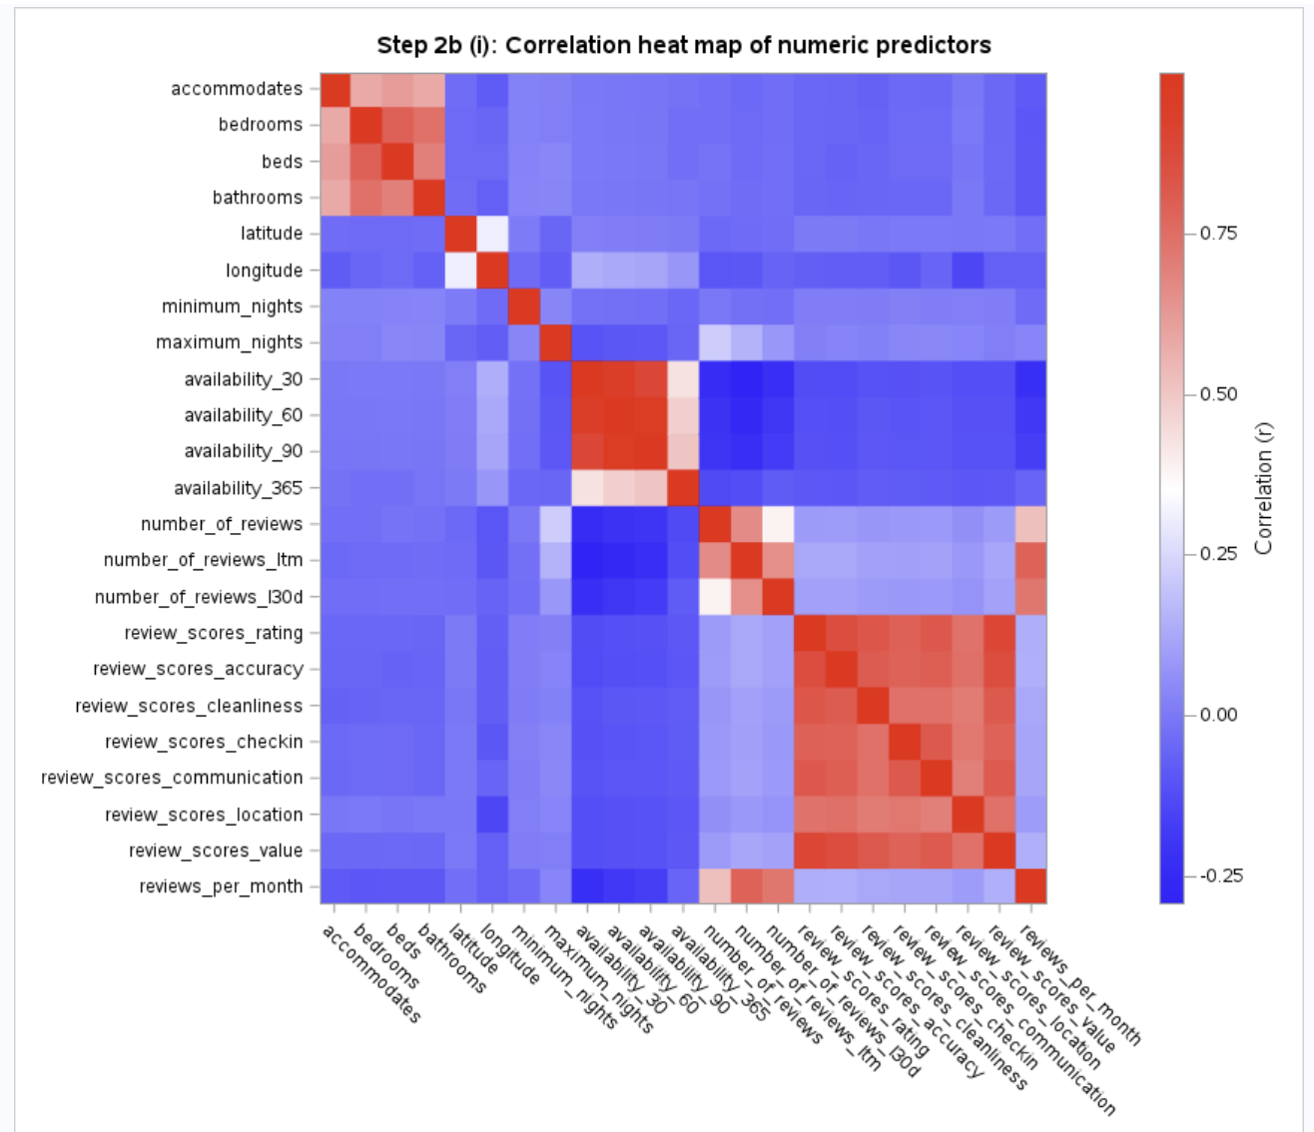

Figure 18: Pairs of numeric predictors with |r| ≥ 0.70
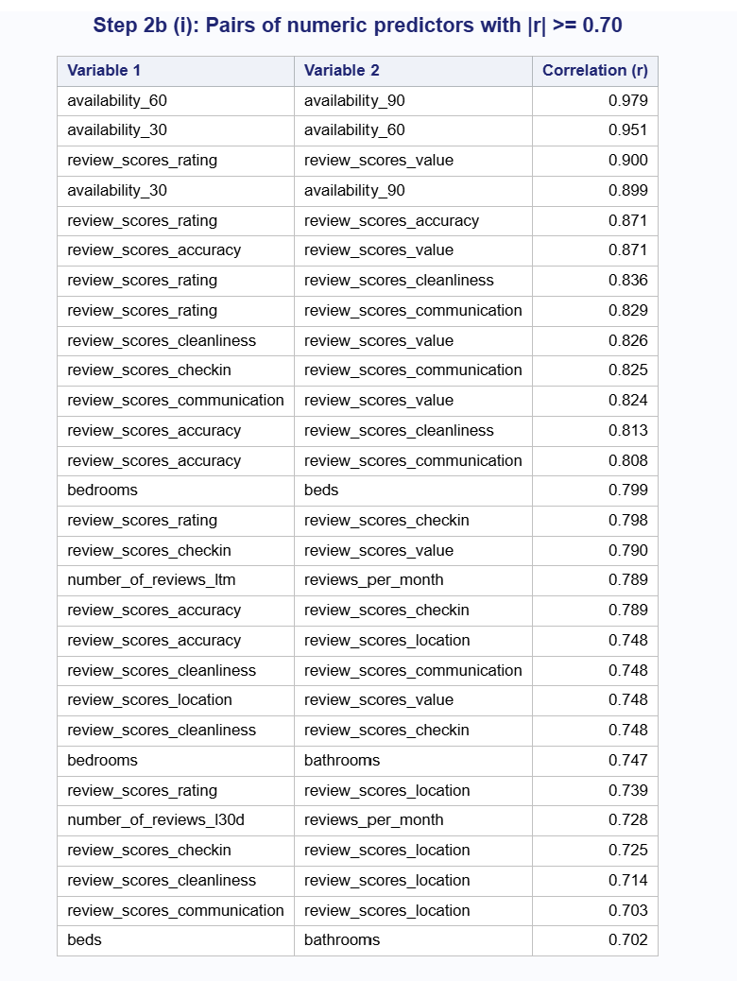
Figure 19: VIF check – all numeric predictors
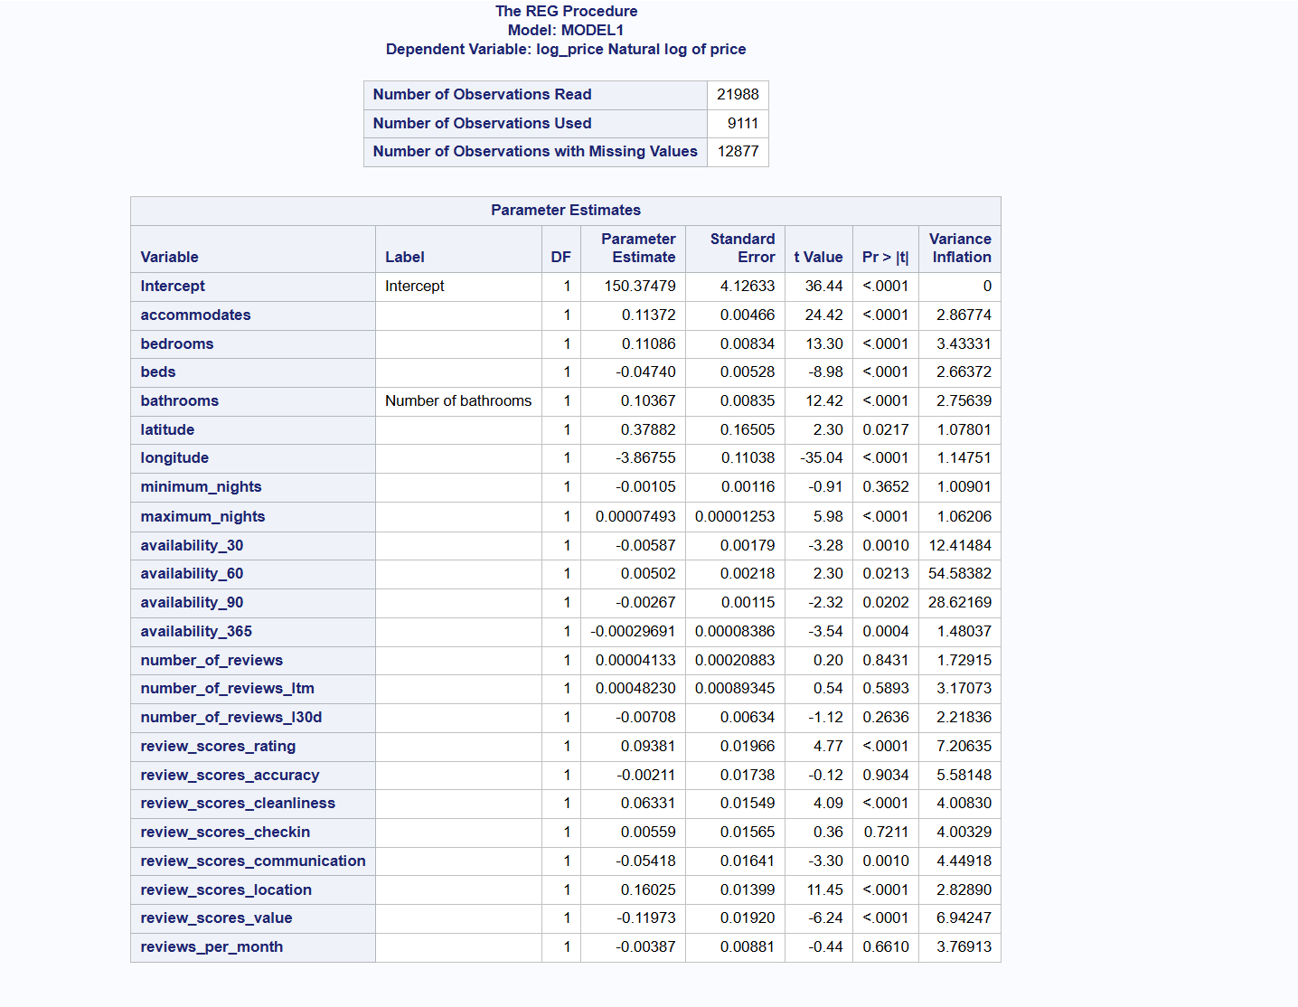
Figure 20: VIF check – after removing highly correlated predictors
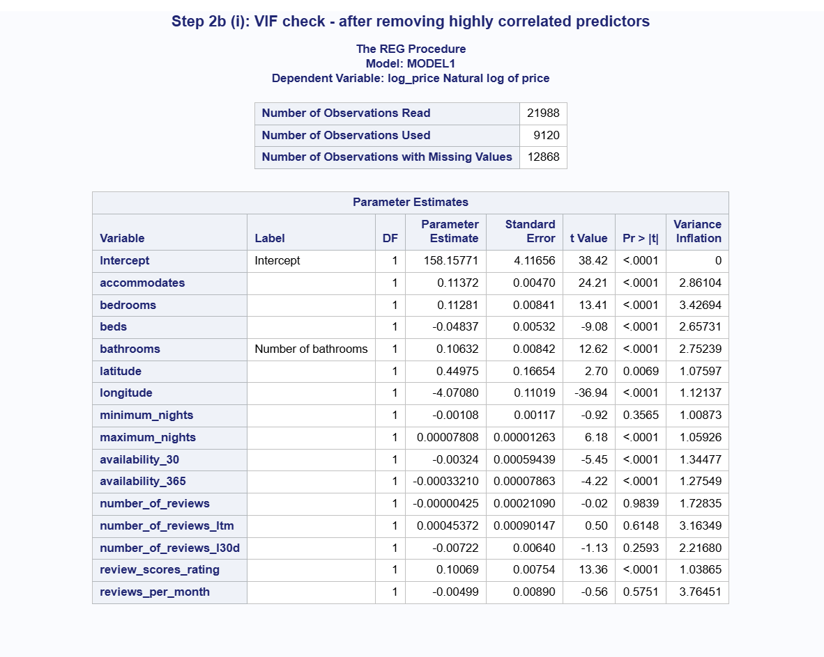

2. Categorization
I used PROC FREQ to check the categorical variables for too many levels. Figure 21 summarises the number of levels in each variable, and how many of those levels have fewer than 20 listings or only one listing.
Figure 21: Number of levels in each categorical variable
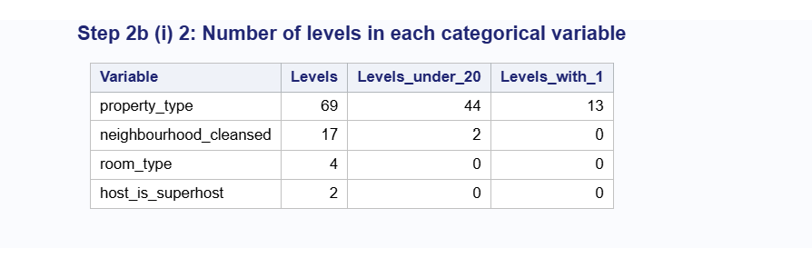
Three variables needed to be collapsed:
- property_type has 69 levels. Most listings are in a few types: Entire rental unit alone has 14,811 listings (67.36%), followed by Private room in rental unit (1,697), Entire serviced apartment (1,355) and Entire condo (1,247) (Figure 22). Many types are very small, though: 44 of the 69 types have fewer than 20 listings, and 13 have only one listing (for example, Bus, Campsite, Dome, Hut and Shared room in cave). Levels this small cannot give reliable estimates in a regression model.
- neighbourhood_cleansed has 17 levels, ranging from Kilimani with 9,440 listings (42.93%) down to Embakasi North (6) and Mathare (5), which have fewer than 20 listings each. Seven neighbourhoods have fewer than 100 listings (Figure 23).
- room_type has 4 levels, but Hotel room (58 listings, 0.26%) and Shared room (28 listings, 0.13%) are very small (Figure 23).
- host_is_superhost has only 2 levels (f = 18,849, t = 3,139), so it did not need to be collapsed.
Figure 22: 15 most common property types (of 69)
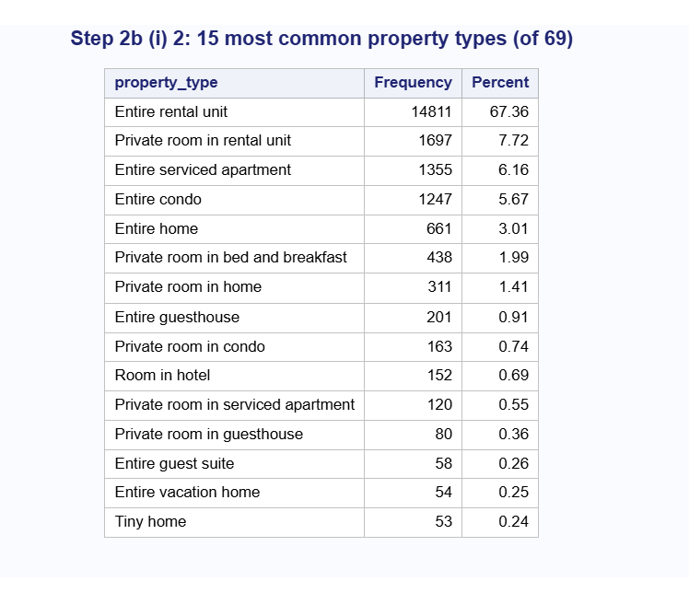
[Insert Figure 23: Frequency tables before collapsing – neighbourhood_cleansed, room_type and host_is_superhost
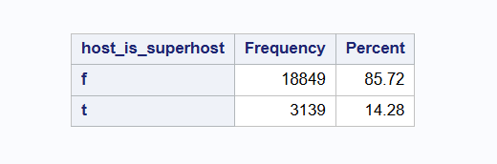
How the levels were collapsed:
property_type → property_group (4 levels). Because room_type already shows whether a listing is an entire place, a private room or a shared room, I grouped property_type by type of building:
- Rental unit: 16,523 listings (75.15%)
- Condo/serviced apartment (condos, serviced apartments and lofts): 2,950 (13.42%)
- House and other (homes, townhouses, villas, cottages, bungalows, guesthouses, guest suites, cabins and unique stays such as tents and treehouses): 1,839 (8.36%)
- Hotel/B&B (hotels, boutique hotels, aparthotels, bed and breakfasts, pensions and resorts): 676 (3.07%)
neighbourhood_cleansed → area (6 levels). I grouped neighbourhoods by their location in Nairobi:
- Kilimani: 9,440 (42.93%)
- South-West (Kibra, Langata, Dagoretti): 4,488 (20.41%)
- North (Roysambu, Kasarani, Ruaraka, Mathare): 2,697 (12.27%)
- East (Embakasi East, South, West, Central and North, and Makadara): 2,129 (9.68%)
- Westlands: 1,747 (7.95%)
- CBD (Starehe, Kamukunji): 1,487 (6.76%)
Kilimani and Westlands were kept as their own groups because they are large, well-known areas with the highest prices. Figure 24 confirms that each of the 17 neighbourhoods was placed in the correct area.
Figure 24: Neighbourhoods assigned to each area
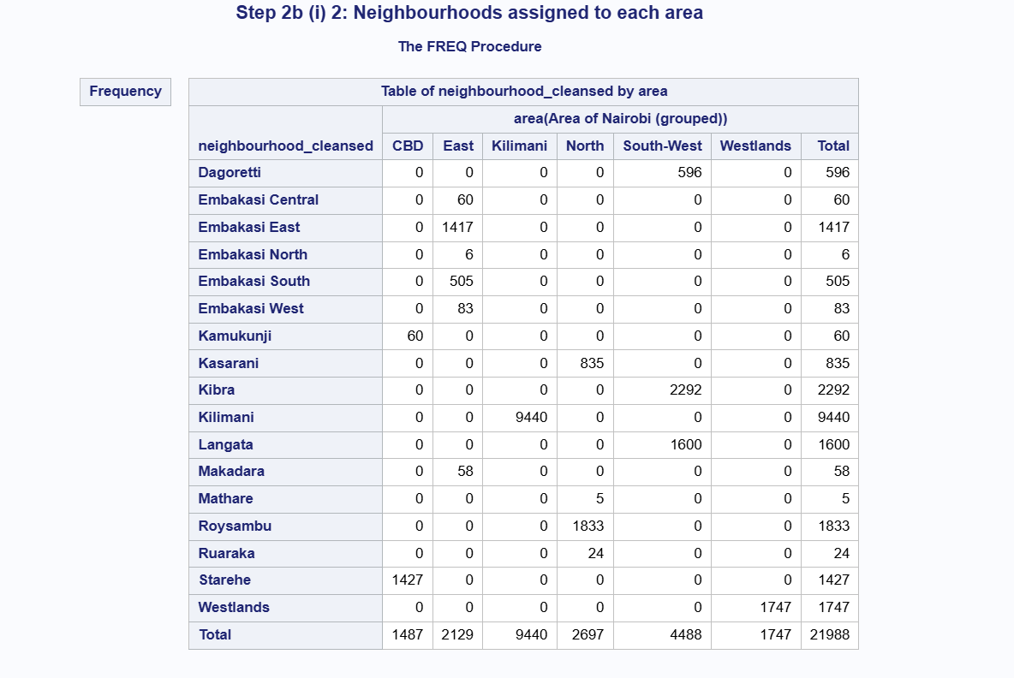
room_type → room_group (3 levels). Hotel room and Shared room were combined into Hotel/shared room (86 listings). The other levels stayed the same: Entire home/apt (18,665) and Private room (3,237).
Result. After collapsing (Figure 25), every level has at least 86 listings, and most groups within each variable are now within the same order of magnitude. Some imbalance remains: Rental unit (75.15%) and Kilimani (42.93%) are still the largest groups, and Hotel/shared room is still small (86 listings). This reflects the actual Nairobi market, where most listings are apartments in rental buildings and many are in Kilimani. Splitting these groups further would not be meaningful.
Insert Figure 25: Categorical variables after collapsing
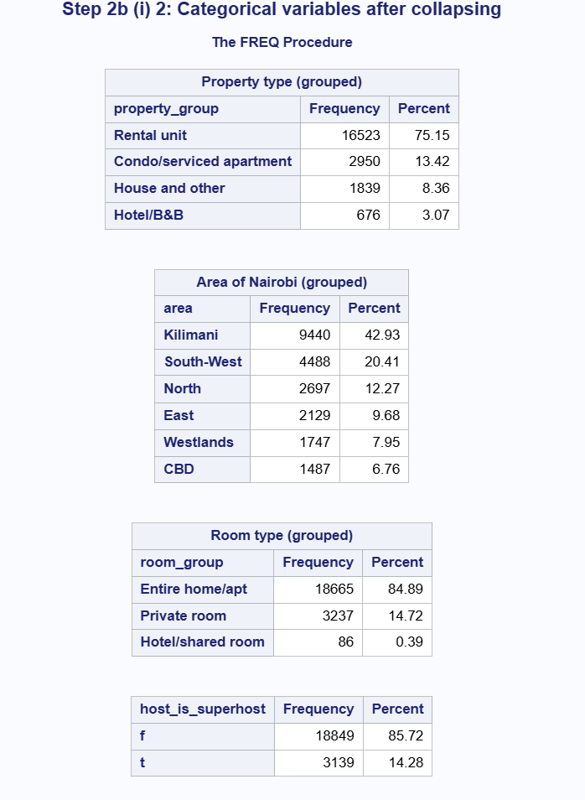

The mean log(price) in each new group (Figure 26) shows that the groups differ in price, so they are useful predictors:
3. Missing Values
I used PROC MEANS to count the missing values in the 15 numeric predictors kept after the multicollinearity check (Figure 27). Out of 21,988 listings:
- No missing values: accommodates, latitude, longitude, availability_30, availability_365, number_of_reviews, number_of_reviews_ltm and number_of_reviews_l30d.
- A small number of missing values (well under 5%): bedrooms (23, 0.10%), beds (369, 1.68%), bathrooms (118, 0.54%), minimum_nights (4, 0.02%) and maximum_nights (4, 0.02%).
- A large number of missing values: review_scores_rating and reviews_per_month (12,700 each, 57.76%).

Figure 27: Missing values in numeric predictors (before)]
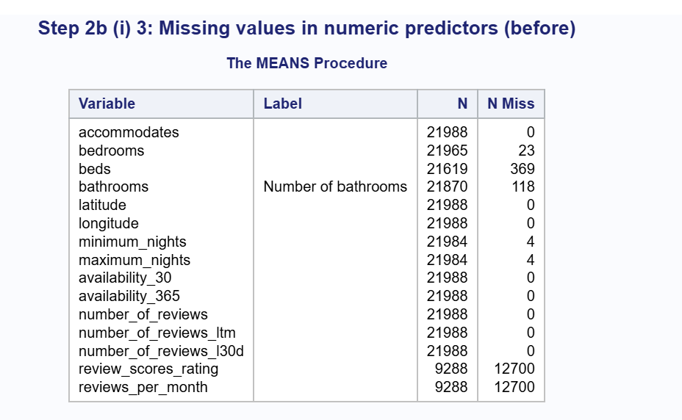
Review scores and reviews per month.
Before deciding how to handle these two variables, I checked why they were missing. Figure 28 shows that all 12,700 listings with a missing review score, and all 12,700 with a missing reviews_per_month, are exactly the 12,700 listings that have zero reviews. The values are not lost or wrongly recorded. These listings simply have not been reviewed yet, so there is no score to report.
Figure 28: Missing review scores compared with number of reviews
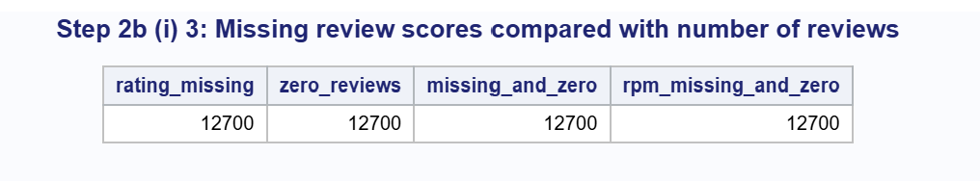
Because of this:
- reviews_per_month was set to 0 for listings with no reviews. This is the correct value rather than an estimate, because a listing with no reviews has 0 reviews per month.
- review_scores_rating is missing for 57.76% of listings, far above the 5% limit for imputation, so filling it with an average would not be appropriate. Leaving it as it is would make SAS drop more than half of the listings from the models. Instead, I turned the rating into a categorical variable, rating_group, with “No reviews” as its own level: No reviews (12,700), Below 4.5 (1,474), 4.5 to 4.79 (1,983), 4.8 to 4.94 (1,786) and 4.95 to 5.0 (4,045). The cut-off points were chosen so that the four rated groups have similar counts, in the same order of magnitude. This keeps the information from the ratings while keeping all listings in the model. The original numeric review_scores_rating will not be used in the models.
Figure 29 shows that the rating groups differ in price. Listings rated 4.8 to 4.94 (mean log price 8.745) and 4.95 to 5.0 (8.720) are more expensive than listings rated 4.5 to 4.79 (8.567) or below 4.5 (8.522). Listings with no reviews fall in between (8.646).

Figure 29: Listings and mean log(price) by review rating group

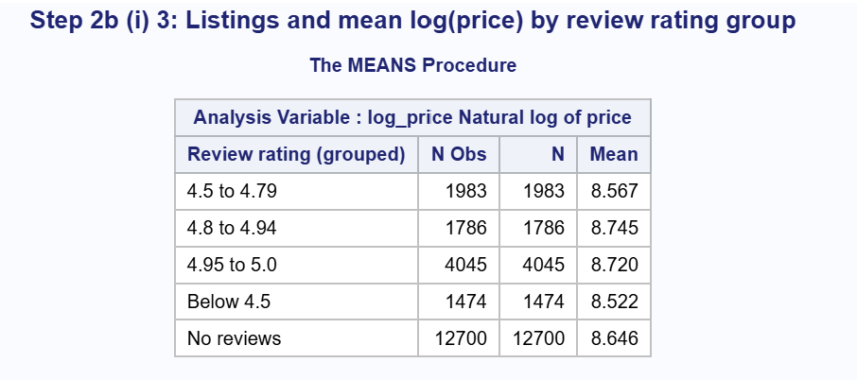

Bedrooms, beds, bathrooms and nights. These five variables have fewer than 2% missing values, so imputation is appropriate. I filled the missing values with the median (using PROC STDIZE with the REPONLY option, which replaces only the missing values and leaves all other values unchanged). I used the median rather than the mean for two reasons. First, the mean would give values that are not real counts, such as 1.49 bedrooms. Second, these variables include a few very large listings that pull the mean up, while the median is not affected by them. The values used were: bedrooms = 1, beds = 1, bathrooms = 1, minimum_nights = 1 and maximum_nights = 365.

The shared_bath flag (created from bathrooms_text) was missing for the same 118 listings with no bathroom information. These were set to 0 (private bathroom), the most common value.

Result. All of these changes were saved in a new data set, AIRBNB.NAIROBI_FINAL, so the earlier data set stays unchanged. After these steps, none of the numeric predictors used in the models has any missing values (Figure 30). All 21,988 listings can be used in the models.
Figure 30: Missing values in numeric predictors (after)]

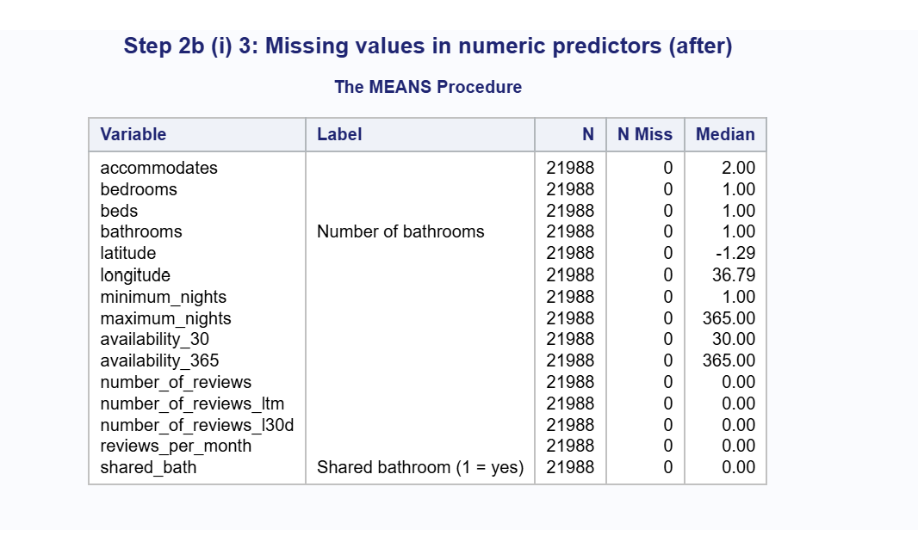

Feature Engineering and Standardizing
To decide whether any numeric predictors needed to be transformed or given higher-order terms, I plotted log(price) against the main numeric predictors. Each plot includes a smoothed line (a penalized B-spline) that shows the general shape of the relationship. At the far ends of some plots, where there are only a few listings, the line swings up and down sharply. These swings follow a handful of points and do not show a real pattern, so I focused on the parts of each plot where most listings are.
Accommodates (Figure 31). Price rises clearly as the number of guests increases, from about 8.3 on the log scale for 1 guest to about 9.8 for 9 guests. After that, the line levels off and then falls for the largest listings. Because the relationship is curved rather than a straight line, I added a squared term for accommodates.
[Insert Figure 31: log(price) vs accommodates]
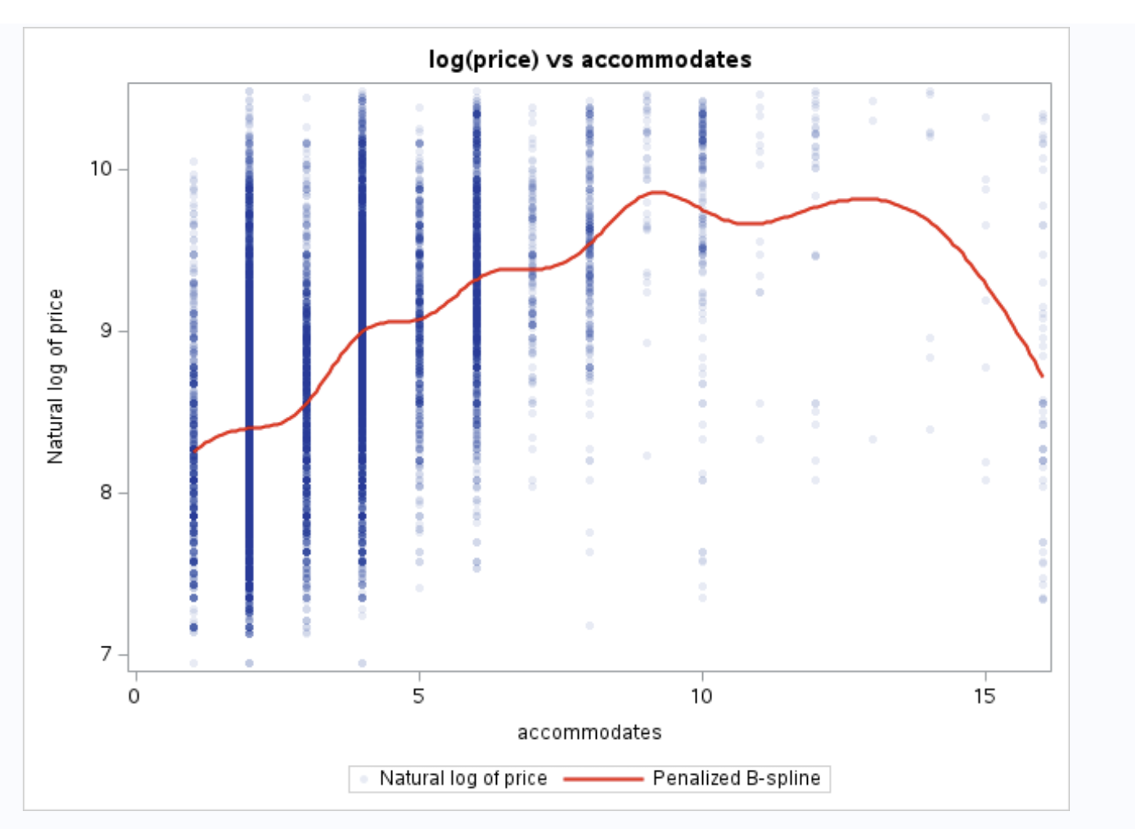
Bedrooms (Figure 32).
Almost all listings have between 0 and 5 bedrooms, and in that range price rises with the number of bedrooms. A small number of listings report very large numbers (up to 50 bedrooms). These stretch the x-axis and squash the main relationship into the left side of the plot. The same pattern was found for beds and bathrooms. Figure 33 shows how strongly skewed these three variables are: skewness of 15.83 (bedrooms), 14.05 (beds) and 16.75 (bathrooms).
To reduce the skew, I applied a log(x + 1) transformation to bedrooms, beds and bathrooms. This is the log(Y + a) transformation from the table in the instructions, with a = 1. Adding 1 is needed because some listings (studios) have 0 bedrooms, and the log of 0 cannot be calculated. After the transformation, skewness fell to 0.53 (bedrooms), 1.96 (beds) and 1.67 (bathrooms) (Figure 33). Figure 34 shows that the relationship between log(bedrooms + 1) and log(price) is now much clearer: price rises steadily from 0 to about 5 bedrooms.
[Insert Figure 32: log(price) vs bedrooms]

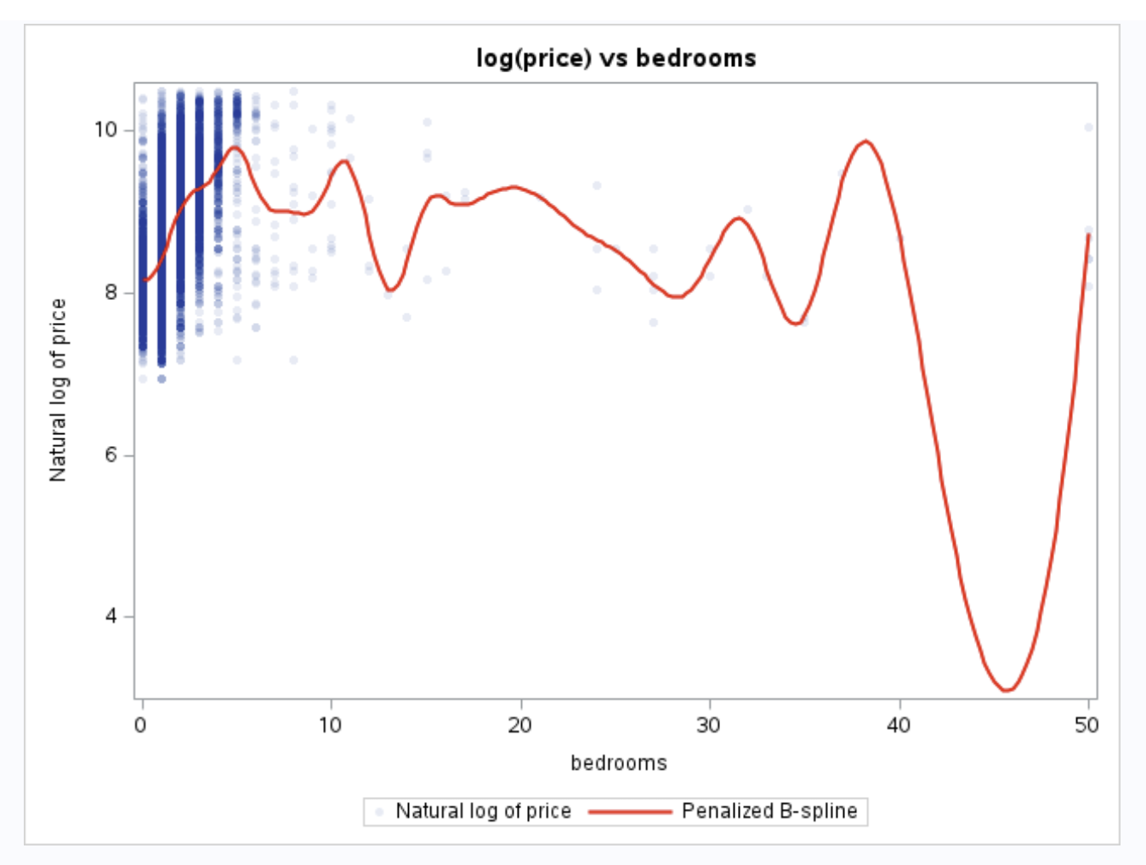
[Insert Figure 33: Skewness before and after log(x + 1)]
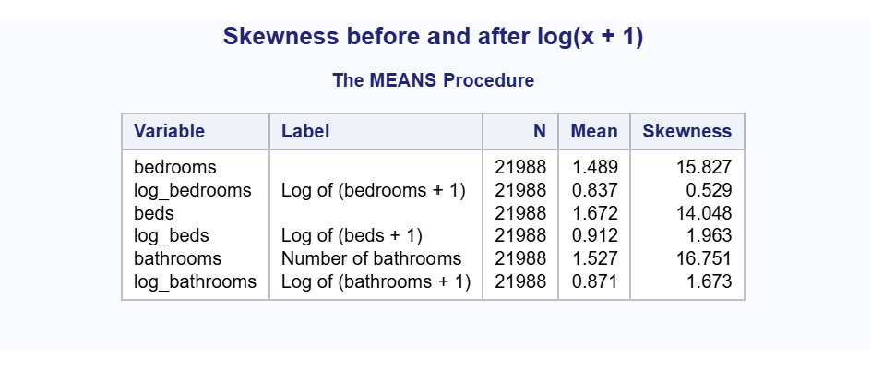
[Insert Figure 34: log(price) vs log(bedrooms + 1)]
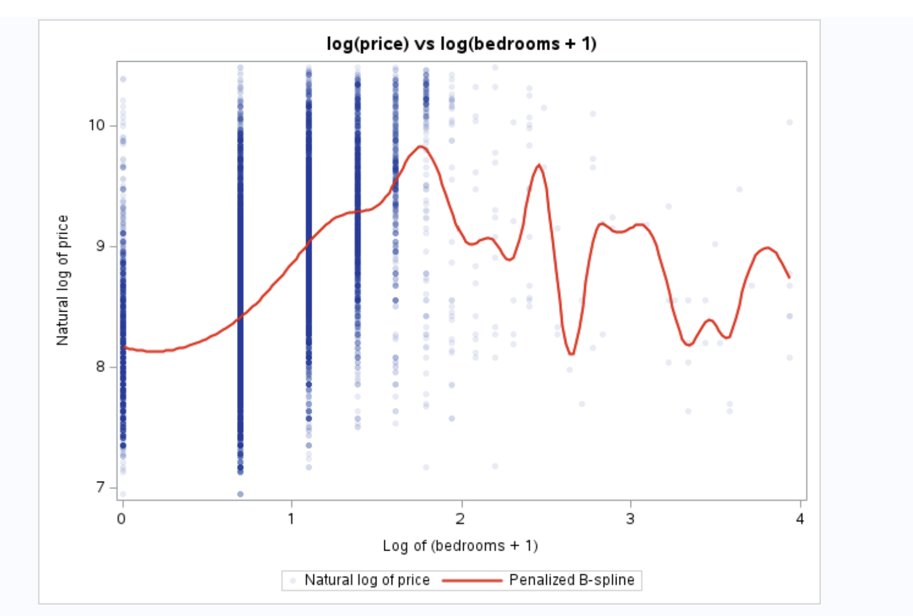
Latitude (Figure 35).
The relationship with latitude is not a straight line. Prices are highest in the middle band, between about −1.30 and −1.26, which is where Kilimani and Westlands are located. Prices are lower to the north, around −1.22, where Roysambu and Kasarani are located. To capture this curve, I added a squared term for latitude.
[Insert Figure 35: log(price) vs latitude]
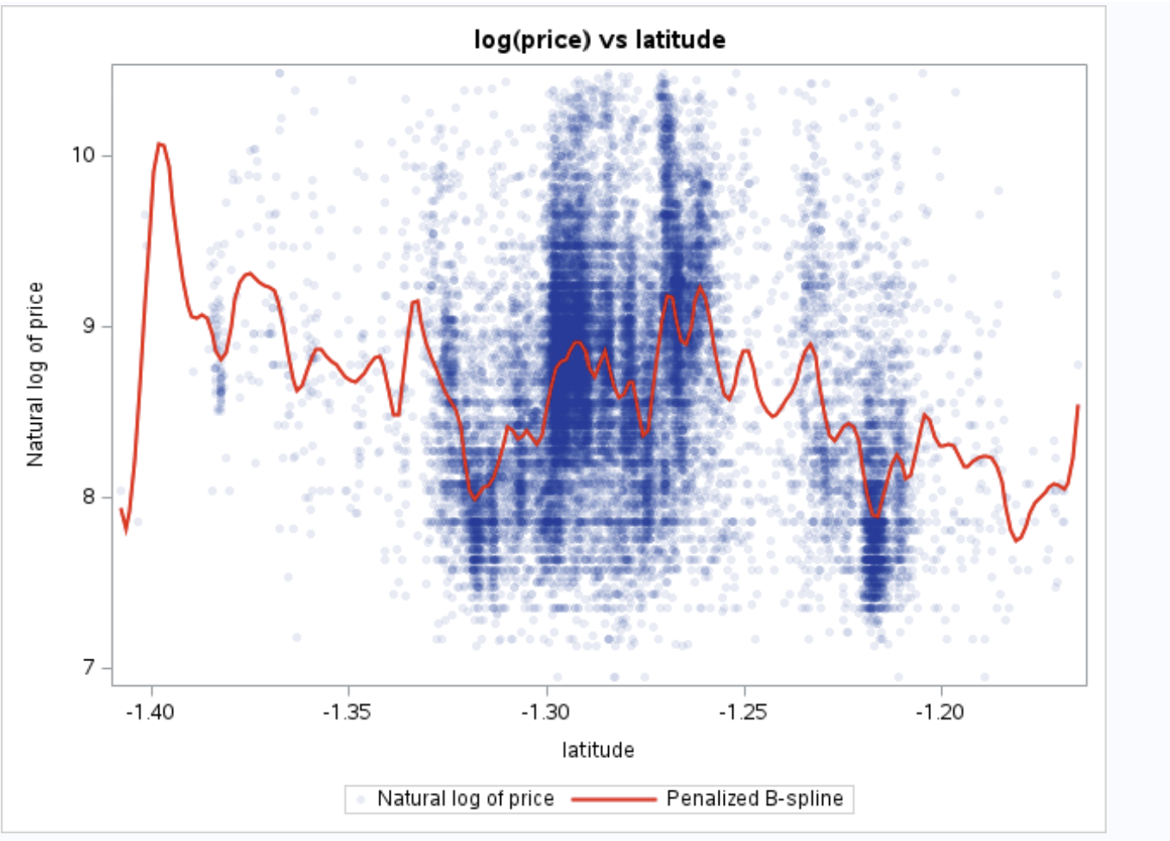
Longitude (Figure 36).
Price falls from west to east across Nairobi. Listings in the west, around 36.78 to 36.81 (Kilimani and Westlands), have the highest prices, and listings further east (Embakasi) have lower prices. The relationship is slightly curved, so I also added a squared term for longitude. The deep dip at the far right of the plot (around 37.04) is caused by the smoothed line passing through an area with almost no listings, so it does not reflect a real pattern.
[Insert Figure 36: log(price) vs longitude]
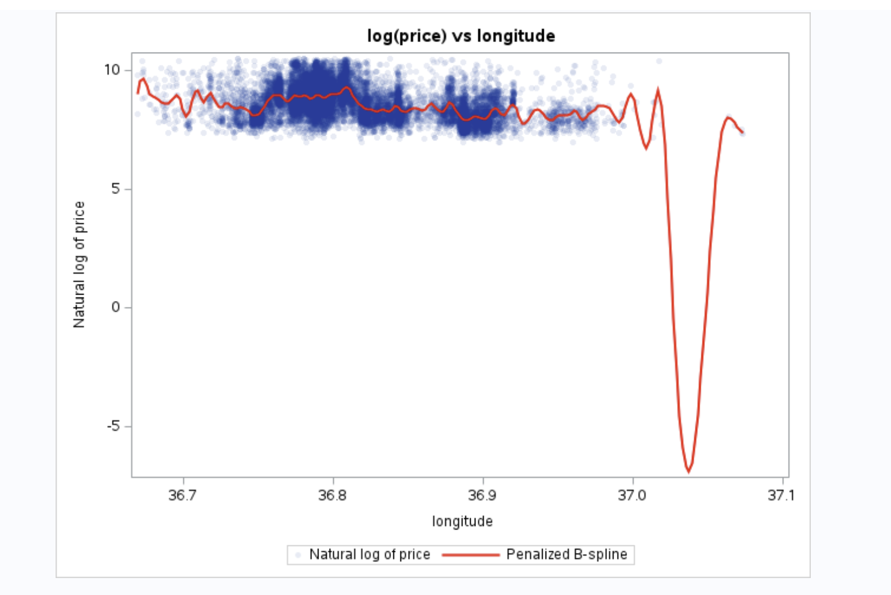Availability (Figure 37).
The line is almost flat, so availability_30 has only a weak link with price. It was kept as it is, with no transformation. The other remaining predictors (availability_365, minimum_nights, maximum_nights and the review count variables) also have weak relationships with price, so they were kept as they are.
[Insert Figure 37: log(price) vs availability_30]
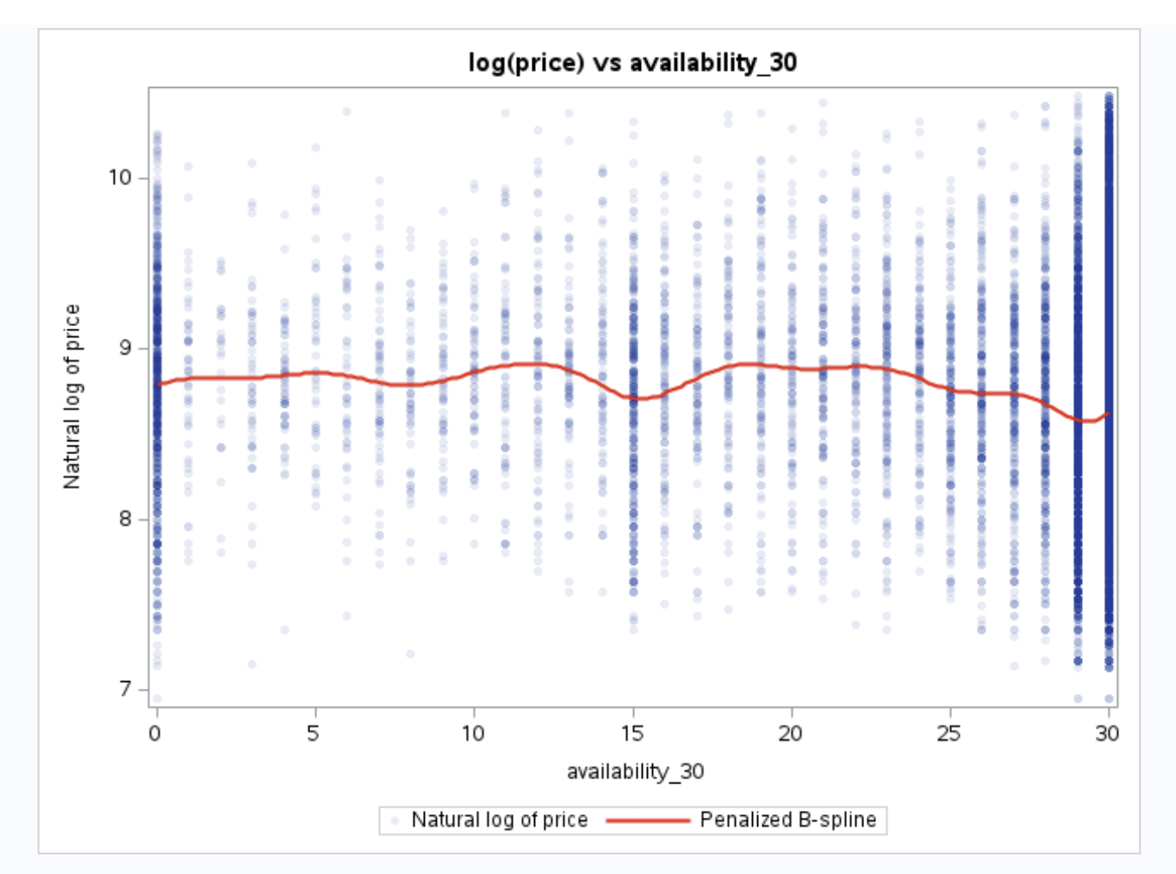
Standardizing.
The numeric predictors are measured on very different scales. For example, latitude varies only between about −1.41 and −1.17, while maximum_nights varies from 2 to 1,125. To bring them to the same scale, I standardized all 14 numeric predictors into z-scores using PROC STDIZE (METHOD=STD). Each standardized variable (with the prefix z_) has a mean of 0 and a standard deviation of 1 (Figure 38). The squared terms were created from the standardized variables (z_accommodates_sq, z_latitude_sq and z_longitude_sq). Centring a variable at 0 before squaring it reduces the correlation between the variable and its square, which helps avoid creating new multicollinearity. The shared_bath flag was not standardized, because it is already a 0/1 variable.
[Insert Figure 38: Standardized and squared variables]
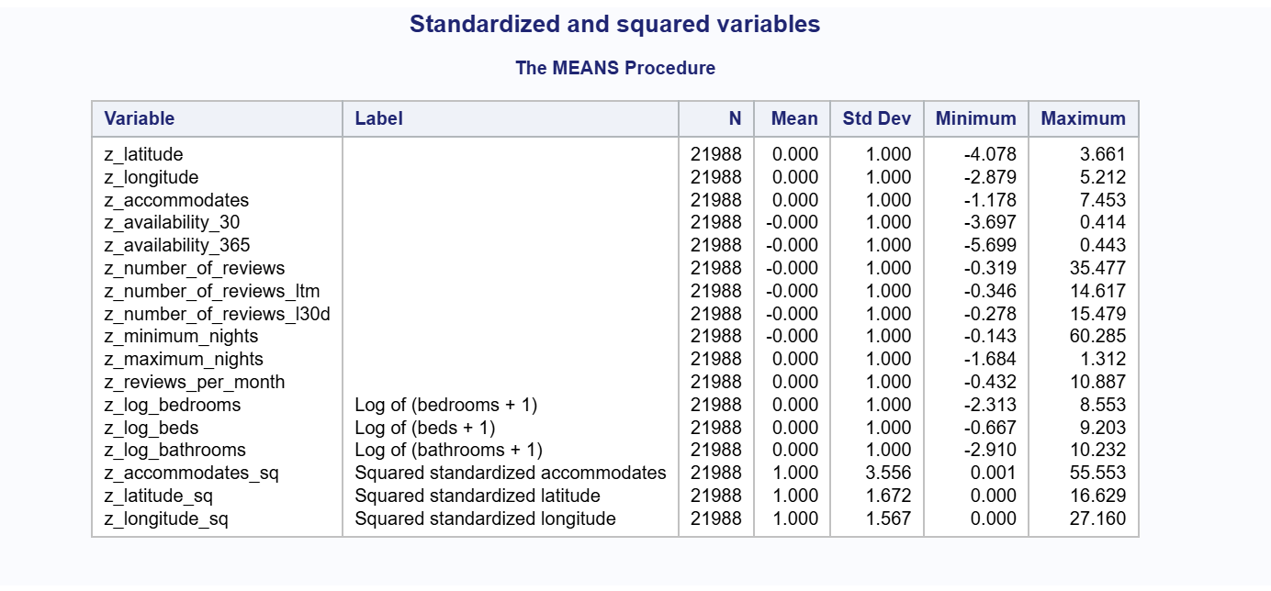
Effect of feature engineering. To check whether these changes improve the model, I fitted a simple regression of log(price) on the numeric predictors before and after the changes (Figures 39 and 40):
Model | R-Square | Adj R-Sq | Root MSE
Original numeric predictors | 0.3963 | 0.3959 | 0.50379
Engineered and standardized predictors | 0.4834 | 0.4830 | 0.46605
The engineered predictors explain 48.3% of the variation in log(price), compared with 39.6% for the original predictors, an increase of about 8.7 percentage points. The Root MSE also fell from 0.504 to 0.466. This confirms that the log transformations and squared terms help capture the relationships with price more accurately. These numeric-only models are used only to compare the predictors. The final models in the next steps will also include the categorical variables.
The final data set, with all of these changes, was saved as AIRBNB.NAIROBI_MODEL. This is the data set that will be split into training and testing samples.
[Insert Figure 39: Model fit – original numeric predictors]
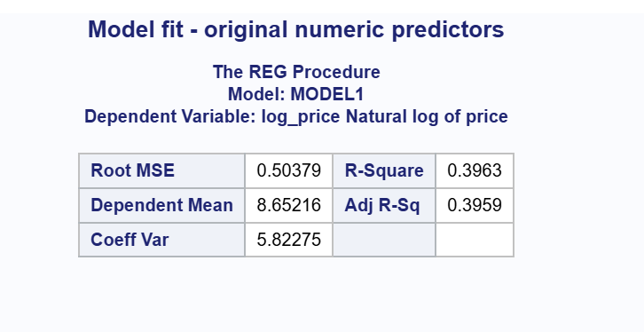
[Insert Figure 40: Model fit – engineered and standardized predictors]
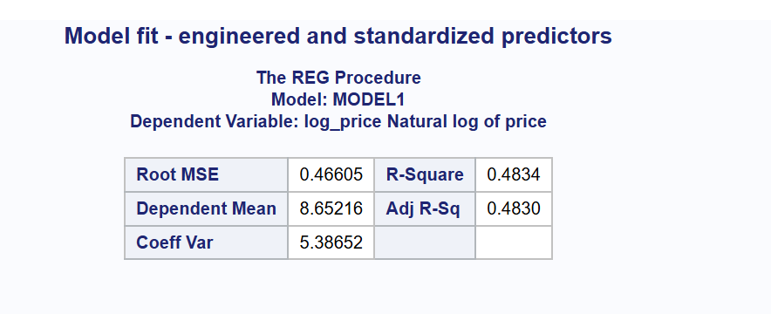

ii. Character (Categorical) Variables
  - Frequency tables.
The frequency tables for property_type, neighbourhood_cleansed and room_type, and how they were collapsed, were presented in Step i.2 (Figures 21 to 26). Figure 41 shows the frequency tables for the other categorical variables used in the models:
- rating_group (created in Step i.3): No reviews 12,700 (57.76%), 4.95 to 5.0 4,045 (18.40%), 4.5 to 4.79 1,983 (9.02%), 4.8 to 4.94 1,786 (8.12%) and Below 4.5 1,474 (6.70%).
- host_is_superhost: not a superhost (f) 18,849 (85.72%) and superhost (t) 3,139 (14.28%).
- shared_bath (created from bathrooms_text in Step i.1): private bathroom (0) 21,368 (97.18%) and shared bathroom (1) 620 (2.82%).
[Insert Figure 41: Other categorical variables used in the models]
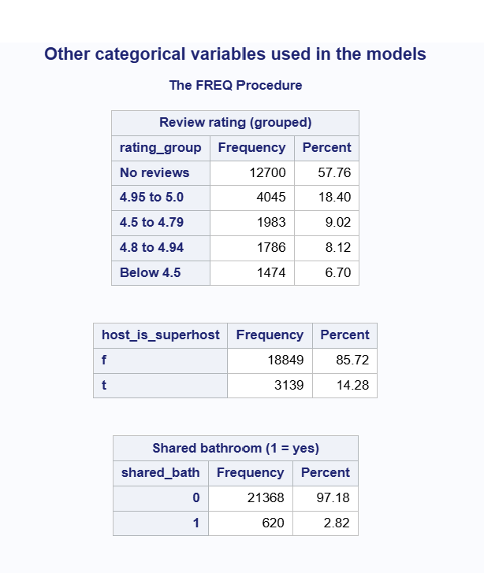
Both host_is_superhost and shared_bath have only two levels, so they did not need to be collapsed. Figures 42 and 43 show that both are related to price:
- Listings from superhosts have a higher mean log price (8.781) than listings from other hosts (8.631), a difference of 0.15, or about 16% higher prices (e^0.15 ≈ 1.16).
- Listings with a shared bathroom have a lower mean log price (8.294) than listings with a private bathroom (8.663), a difference of 0.37, or about 31% lower prices (e^−0.37 ≈ 0.69).
[Insert Figure 42: Mean log(price) by superhost status]
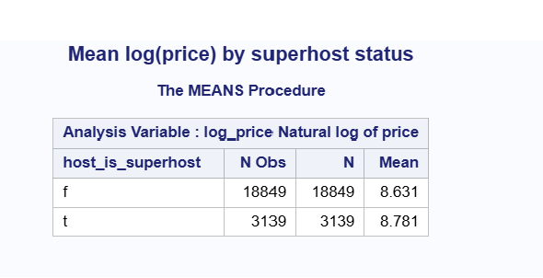

[Insert Figure 43: Mean log(price) by shared bathroom (1 = yes)]

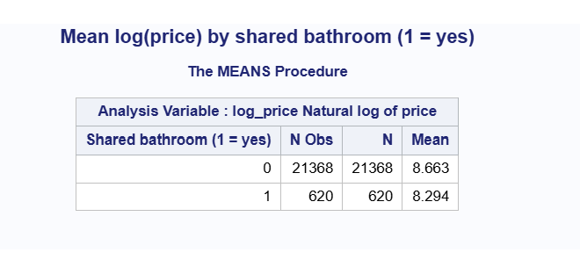
Variables that cannot be used.

Several categorical variables in the data dictionary could not be used because they contain no information for Nairobi (Figure 44). host_response_time, host_response_rate, host_acceptance_rate, instant_bookable and neighborhood_overview are completely empty, with 0 non-missing values out of 21,988 listings. has_availability has a value for 21,980 listings, but only one level (“t” = available). A variable with only one value cannot explain differences in price. These six variables were therefore left out of the models.
[Insert Figure 44: Categorical variables that cannot be used (empty or one value)]
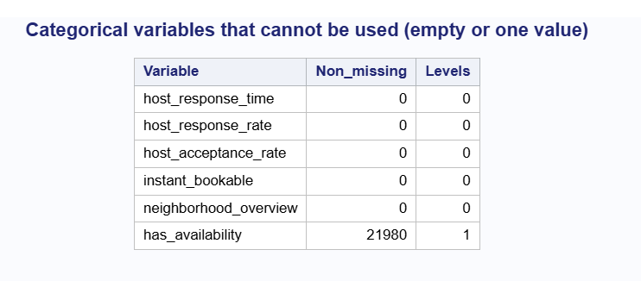

2. Collapsing levels. property_type (69 levels), neighbourhood_cleansed (17 levels) and room_type (4 levels, two of them very small) were collapsed in Step i.2 into property_group (4 levels), area (6 levels) and room_group (3 levels). The review rating was grouped into rating_group (5 levels) in Step i.3. No other categorical variable has too many levels, so no further collapsing was needed.
Summary of predictors for the models. The final data set, AIRBNB.NAIROBI_MODEL (21,988 listings), contains the following predictors:
- Numeric (standardized): z_accommodates, z_log_bedrooms, z_log_beds, z_log_bathrooms, z_latitude, z_longitude, z_minimum_nights, z_maximum_nights, z_availability_30, z_availability_365, z_number_of_reviews, z_number_of_reviews_ltm, z_number_of_reviews_l30d and z_reviews_per_month
- Squared terms: z_accommodates_sq, z_latitude_sq and z_longitude_sq
- Categorical: property_group, area, room_group, rating_group, host_is_superhost and shared_bath
- Dependent variable: log_price

c. Splitting the Data into Training and Testing Samples
I split the 21,988 listings in AIRBNB.NAIROBI_MODEL into a training sample (80%) and a testing sample (20%), following Programs 2.4 and 2.5. An 80/20 split is a common, accepted ratio. It leaves enough listings to train the models while keeping a separate group of listings to test how well the models predict prices they have not seen.
I used PROC SURVEYSELECT with simple random sampling (METHOD=SRS) and a sampling rate of 0.80 (Figure 45). The OUTALL option keeps every listing in the output and adds a variable, Selected, which is 1 for listings chosen for training and 0 for the rest. I set a random number seed (SEED=12345) so that the same split is produced every time the program runs. This is important because the LASSO regression, decision tree and random forest models must all be trained and tested on the same listings for a fair comparison.
All data changes (removing outliers, handling missing values, collapsing categories, transforming and standardizing variables) were made before the split, so they apply equally to both samples and do not need to be repeated.
Figure 45: PROC SURVEYSELECT – sample selection
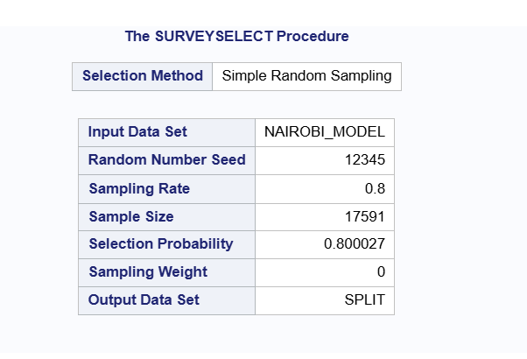

The training sample (AIRBNB.TRAIN) contains 17,591 listings (80.00%) and the testing sample (AIRBNB.TEST) contains 4,397 listings (20.00%) (Figure 46).
[Insert Figure 46: Number of listings in the training and testing samples]
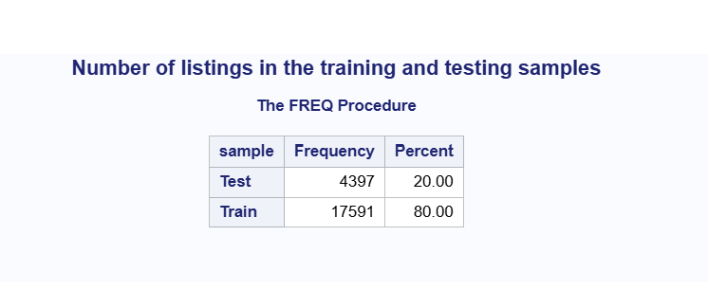
To check that the random split produced two similar samples, I compared them on the dependent variable and on two key predictors:
- log(price) (Figure 47): the mean is 8.651 in the training sample and 8.659 in the testing sample, and the standard deviations are 0.647 and 0.654. The minimum (6.943) is the same in both, and the maximums are close (10.486 and 10.455).
- Room type (Figure 48): the percentages are almost the same. For example, Entire home/apt makes up 84.91% of the training sample and 84.81% of the testing sample, and Private room 14.68% and 14.87%.
- Area (Figure 48): the percentages are also very close. For example, Kilimani makes up 42.93% of the training sample and 42.96% of the testing sample, and South-West 20.45% and 20.26%.
These small differences are what would be expected from a random split. The two samples represent the same population of listings, so the testing sample gives a fair check of how the models perform on new data.
[Insert Figure 47: log(price) in the training and testing samples]

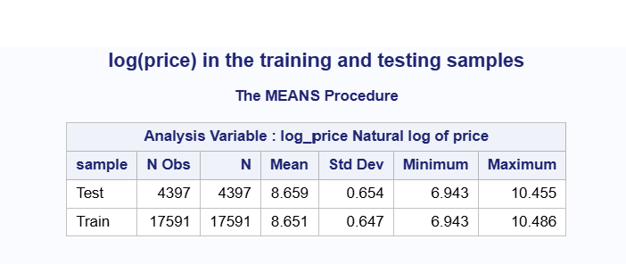
[Insert Figure 48: Room type and area in the training and testing samples (column %)]

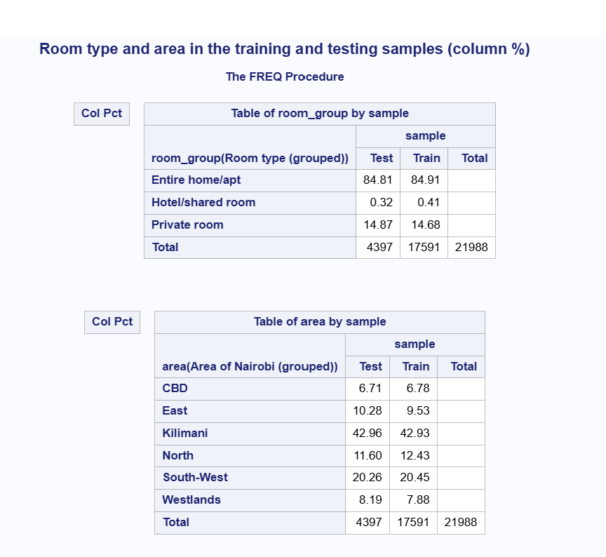

d. LASSO Regression Model (PROC GLMSELECT)
I fitted a linear regression model with LASSO selection using PROC GLMSELECT, following Programs 2.19 and 2.20. The dependent variable is log_price. The model was fitted on the training sample (17,591 listings), and the testing sample (4,397 listings) was supplied with the TESTDATA= option so that SAS also reports the prediction error on new data.
The candidate predictors were the 14 standardized numeric variables, the 3 squared terms (z_accommodates_sq, z_latitude_sq and z_longitude_sq), shared_bath, and the five categorical variables (property_group, area, room_group, rating_group and host_is_superhost), which were listed in the CLASS statement. With the categorical variables split into their levels, there were 39 possible parameters.
How LASSO works. LASSO (Least Absolute Shrinkage and Selection Operator) adds predictors to the model step by step while shrinking their coefficients toward zero. Predictors that add little to the model are kept at zero, which removes them. To choose the best step, I used 10-fold cross-validation (CHOOSE=CV): the training data is split into 10 parts, and the model is repeatedly fitted on 9 parts and tested on the 10th. The step with the lowest cross-validation prediction error (CV PRESS) is selected. The testing sample was not used to choose the model. It was used only to check the final model.
Selection process. The LASSO Selection Summary (Figure 49) shows the order in which predictors entered the model. The first predictors to enter were z_log_bedrooms, z_log_bathrooms, z_accommodates, z_longitude and area_Kilimani, which shows that size and location are the strongest drivers of price. The lowest CV PRESS (3210.31) was reached at step 32, which was selected as the final model.
[Insert Figure 49: LASSO Selection Summary (steps 24 to 37)]
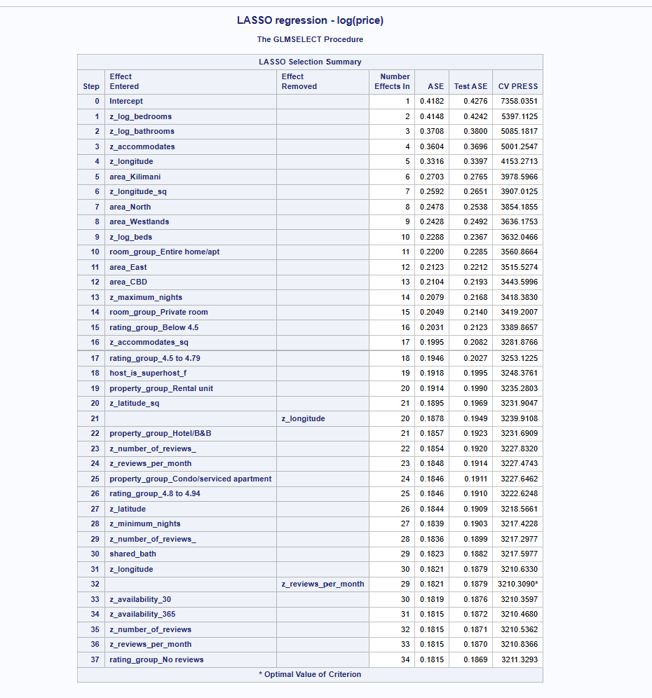

The Coefficient Progression plot (Figure 50) shows how each coefficient grows from zero as more predictors enter. z_accommodates has the largest positive coefficient, followed by area_Westlands and z_log_bedrooms, while area_East and area_CBD have the largest negative coefficients. The lower panel shows that CV PRESS falls sharply over the first 10 steps and then levels off, with very little improvement after about step 20.
[Insert Figure 50: Coefficient Progression for log_price]
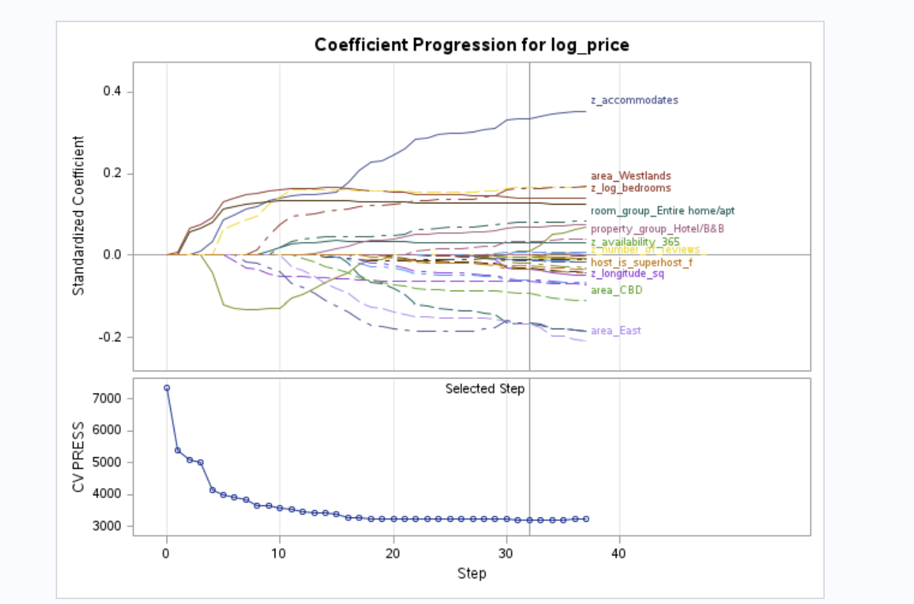

The Average Squared Error plot (Figure 51) shows the error for the training and testing samples at each step. Both fall together, and the testing error stays only slightly above the training error at every step. This shows that the model is not overfitting: it predicts new listings almost as well as the listings it was trained on.
[Insert Figure 51: Progression of Average Squared Errors by Role for log_price]
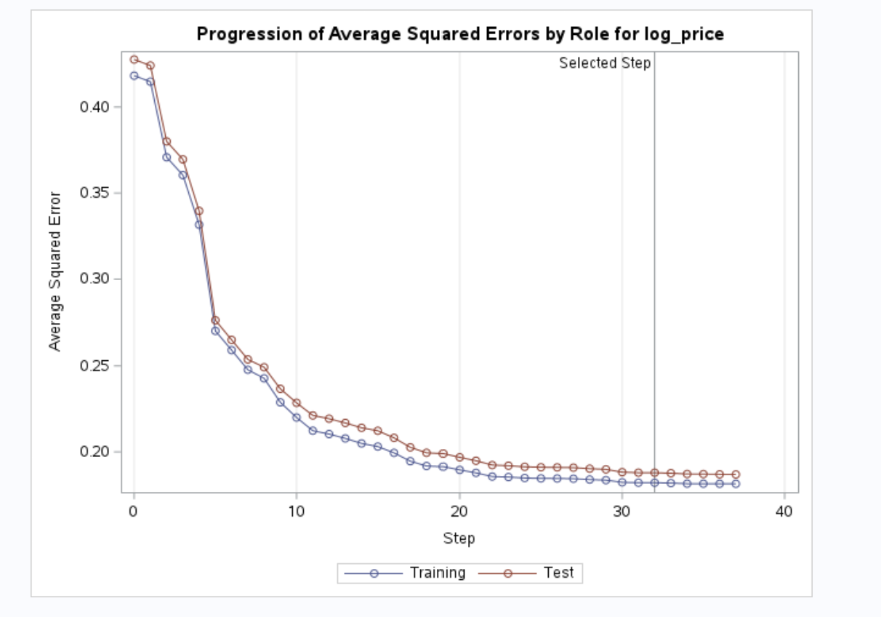

Selected model. The final model contains 28 effects (Figure 52). LASSO removed five candidates: z_availability_30, z_availability_365, z_number_of_reviews, z_reviews_per_month and the “No reviews” level of rating_group. This agrees with the plots in Step b.i.4, which showed that availability and review counts have only a weak link with price.
The model is statistically significant overall (F = 813.32, Figure 52). Its fit statistics are:
- R-Square = 0.5646 (Adj R-Sq = 0.5639): the model explains about 56% of the variation in log(price). This is a clear improvement on the 48% explained by the numeric predictors alone in Step b.i.4, which shows that the categorical variables (especially area and room type) add useful information.
- ASE (Train) = 0.18210 and ASE (Test) = 0.18793.
[Insert Figure 52: Selected model – effects, Analysis of Variance and Fit Statistics]
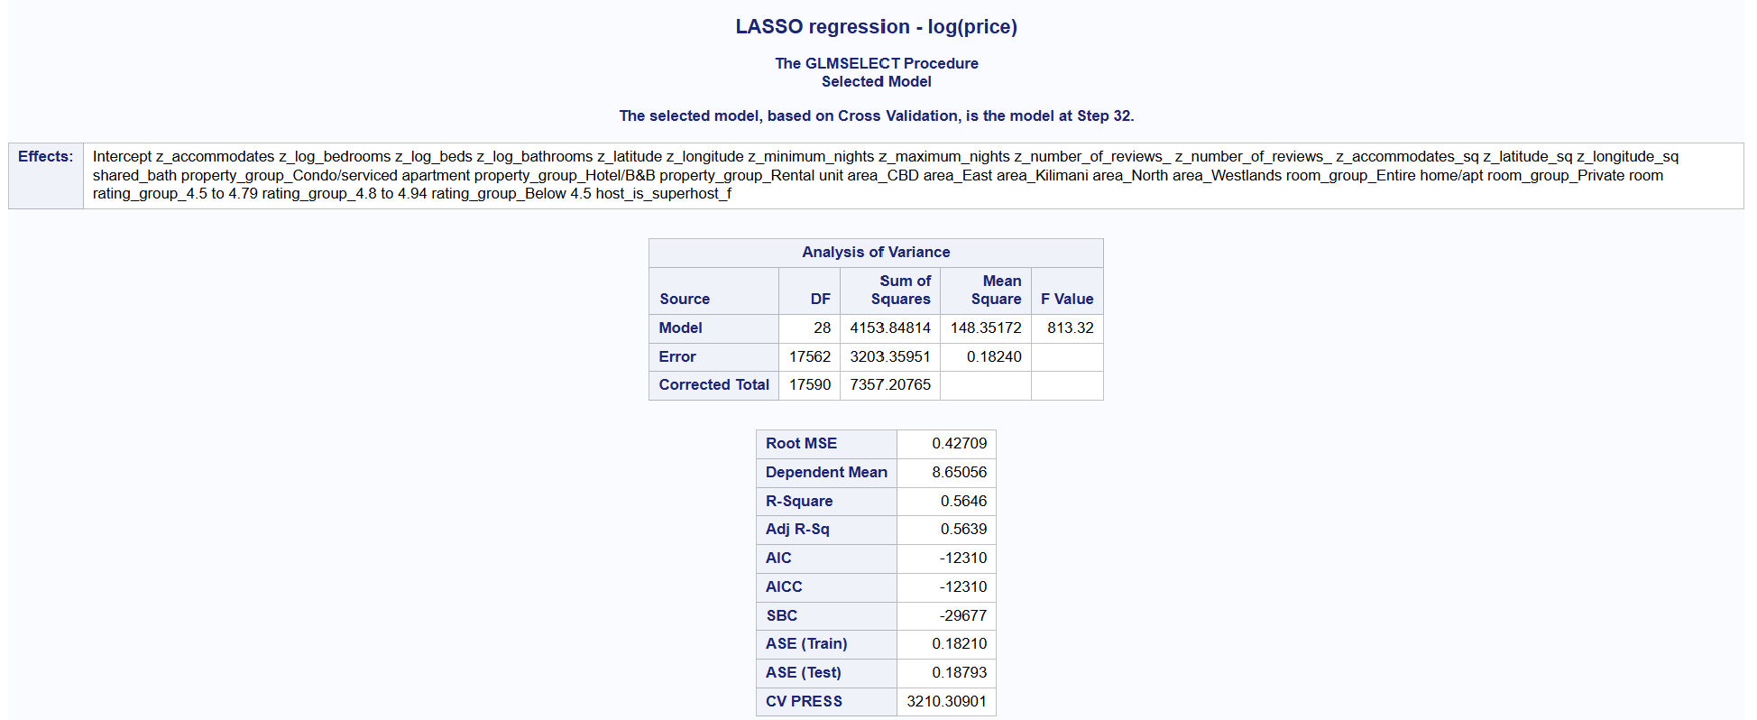

Interpreting the coefficients (Figure 53). Because the dependent variable is log(price), a coefficient b means that price changes by about (e^b − 1) × 100%. Categorical coefficients are compared with the reference level of each variable, which is the last level in alphabetical order (South-West for area, Hotel/shared room for room_group, House and other for property_group, 4.95 to 5.0 for rating_group, and t for host_is_superhost).
- Location has the largest effects. Compared with South-West, listings in Westlands are about 48% more expensive (b = 0.389) and listings in Kilimani about 24% more expensive (b = 0.216). Listings in the East are about 31% cheaper (b = −0.370), in the North about 27% cheaper (b = −0.320) and in the CBD about 22% cheaper (b = −0.243).
- Size: z_accommodates (0.219), z_log_bedrooms (0.092) and z_log_bathrooms (0.083) all have positive coefficients, so larger listings cost more. The negative coefficient on z_accommodates_sq (−0.032) confirms that the increase slows down for the largest listings, as seen in Figure 31.
- Room type: an entire home/apartment is about 15% more expensive than a hotel/shared room (b = 0.144).
- Reviews: listings rated below 4.5 are about 15% cheaper (b = −0.160), and listings rated 4.5 to 4.79 about 13% cheaper (b = −0.136), than listings rated 4.95 to 5.0.
- Host: listings from hosts who are not superhosts are about 6% cheaper (b = −0.066).
- Shared bathroom: a shared bathroom lowers price slightly (b = −0.019).
The coefficients are shrunk toward zero by LASSO, so they are slightly smaller than ordinary regression coefficients would be. They should be read as the direction and relative size of each effect.
[Insert Figure 53: Parameter Estimates – LASSO selected model]
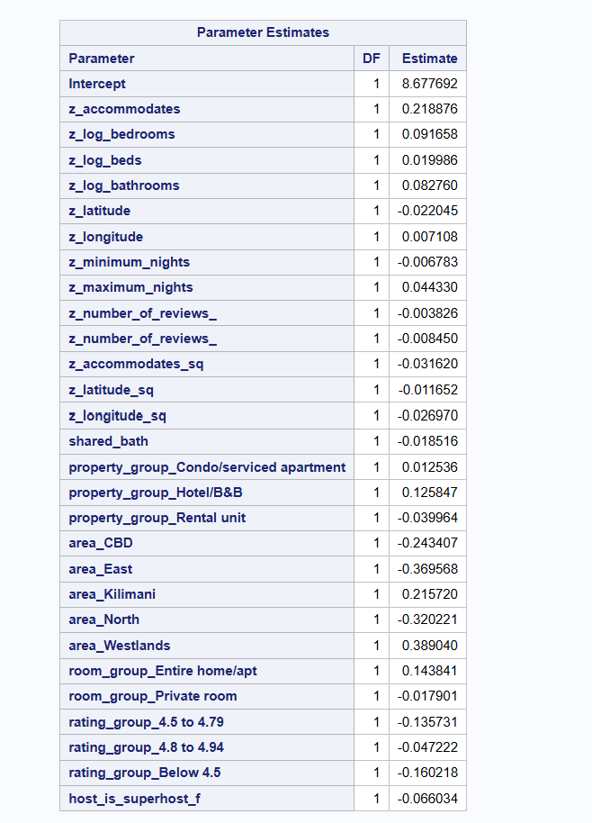

i. Regression Assumptions
I checked the assumptions of linear regression using the residuals (actual minus predicted log price) from the training sample.
Linearity and constant variance (Figure 54). The residuals are scattered around zero across the full range of predicted values, with no clear curved pattern, so the linear model fits the overall relationship reasonably well. The spread of the residuals is fairly constant through the middle of the range, where most listings are. It narrows slightly at the highest predicted values, and the residuals form diagonal edges. This is partly caused by removing the price outliers in Step a.ii: prices are limited to between KES 917 and KES 35,838, so very large positive residuals cannot occur for listings that are already predicted to be expensive. The constant variance assumption is therefore reasonably, but not perfectly, met.
[Insert Figure 54: Residuals vs predicted values (training data)]
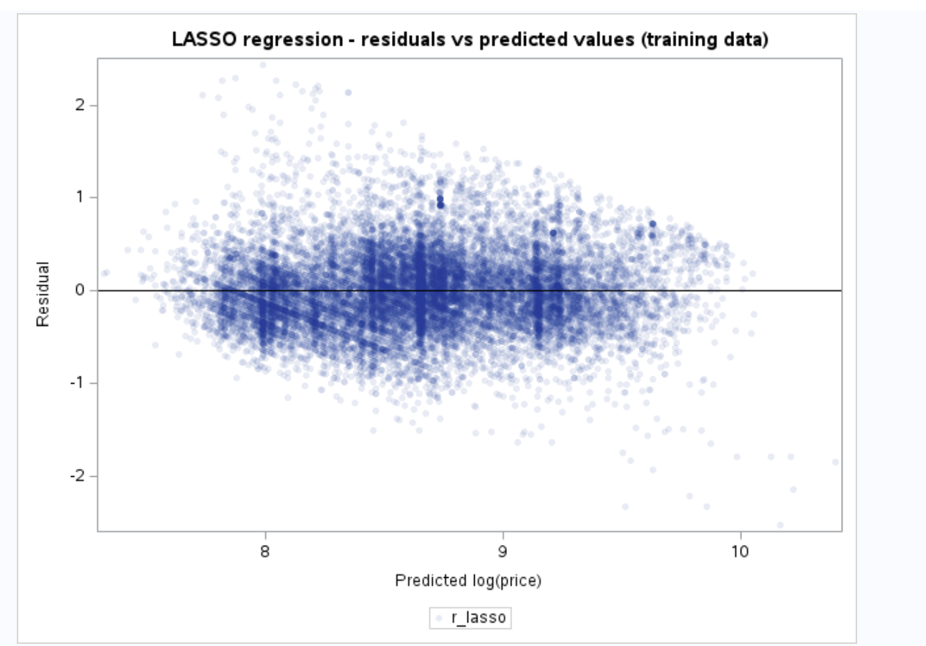
Normality (Figures 55 and 56). The histogram of residuals is bell-shaped and centred at zero (mean = 0, standard deviation = 0.427). The skewness (0.447) is small. The kurtosis (1.769) shows that the tails are somewhat heavier than in a normal distribution. The Q-Q plot follows the straight line closely between about −2 and +2 normal quantiles, which covers about 95% of listings, and moves away from the line only at the extreme ends. With 17,591 listings, small departures in the tails have little effect on the results, so the normality assumption is approximately met.
[Insert Figure 55: Moments and histogram of residuals (training data)] 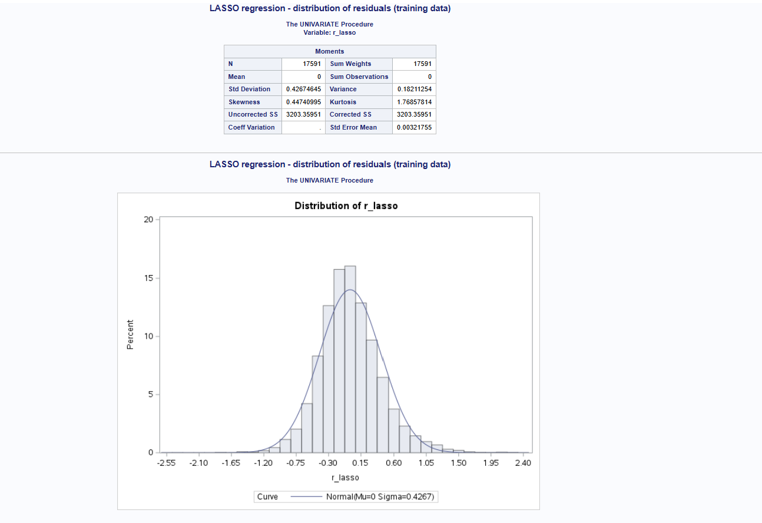

[Insert Figure 56: Q-Q plot of residuals (training data)]
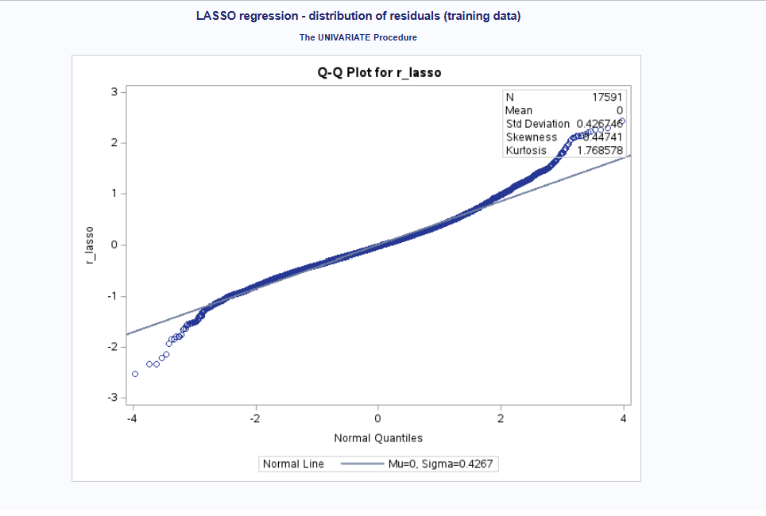
Independence. Each listing is a separate property, so the residuals are expected to be largely independent. Some listings are run by the same host or are in the same building, which may make their prices slightly related. This is a minor limitation.
Multicollinearity. This was dealt with in Step b.i.1 by removing the repeated availability and review score variables. LASSO also reduces the effect of any remaining multicollinearity by shrinking coefficients.
ii. Interpreting the Output: Is the Model Any Good?
The RMSE (Root Mean Square Error) measures the typical size of the prediction error. For the training sample it is the square root of ASE (Train), and for the testing sample the square root of ASE (Test) (Figure 57):
Sample | N | RMSE (log price) | RMSE (KES)
Training | 17,591 | 0.4267 | 3,917
Testing | 4,397 | 0.4335 | 3,882
On the log scale, an RMSE of about 0.43 means that a typical prediction is within about 35% below to 54% above the actual price (e^−0.43 ≈ 0.65 and e^0.43 ≈ 1.54). Converted back to Kenyan Shillings, the typical prediction error is about KES 3,900, compared with an average price of about KES 7,100.
The model is reasonably good:
- It explains about 56% of the variation in log(price) using only information about the listing, its location, its host and its reviews.
- The testing RMSE (0.4335) is almost the same as the training RMSE (0.4267), only 1.6% higher. This shows the model is not overfitting and works just as well on listings it has not seen.
- The coefficients make practical sense: location, size and room type are the main drivers of price.
The model still leaves about 44% of the variation unexplained. Prices also depend on things not in the data, such as the quality of the interior, the view, amenities and the host’s pricing strategy. The decision tree and random forest models in the next steps will test whether a more flexible model can predict prices more accurately than this linear model.
[Insert Figure 57: LASSO regression – RMSE for training and testing samples]


e. Decision Tree Model (PROC HPSPLIT)
I fitted a regression tree with PROC HPSPLIT, following Programs 2.23 and 2.24, with log_price as the dependent variable. The tree was grown on the training sample (17,591 listings). A decision tree splits the listings into smaller and smaller groups using simple rules (for example, “bedrooms < 1.5”), choosing each split to make the prices within each group as similar as possible. The predicted log(price) for a listing is the average log(price) of the final group (leaf) it falls into.
The tree used the same information as the LASSO model, but with the original, unstandardized numeric variables (accommodates, bedrooms, beds, bathrooms, latitude, longitude, minimum and maximum nights, availability and review counts, reviews_per_month and shared_bath) and the five categorical variables. A tree only compares each value with a cut-off point, so standardizing, log transformations and squared terms do not change it. The original units also make the split rules much easier to read.
Growing and pruning the tree. The tree was grown using the variance criterion (GROW VARIANCE), with two branches at each split and a maximum depth of 10 levels. A tree this large fits the training data very closely but tends to predict new data poorly, so it was pruned using cost-complexity pruning (PRUNE COSTCOMPLEXITY) with 10-fold cross-validation. Before pruning the tree had 669 leaves. After pruning it has 153 leaves (Figure 58).
[Insert Figure 58: Decision tree – Model Information]
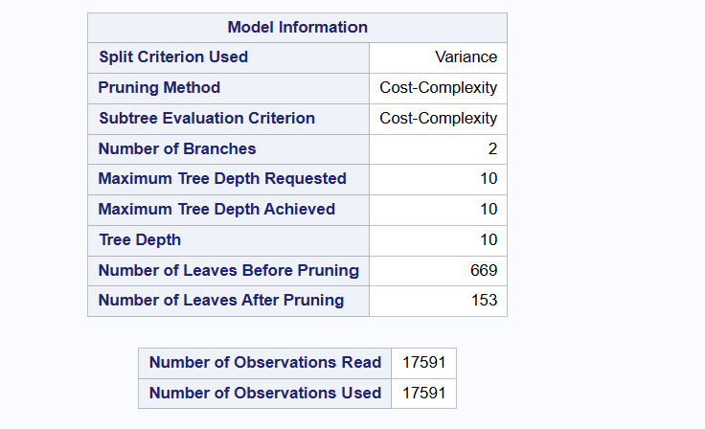

Figure 59 shows the cross-validation results. The average squared error (ASE) falls quickly as the tree grows from 1 to about 50 leaves, reaches its minimum (0.154) at around 155 leaves, and then rises slightly as the tree becomes larger. The rise shows that a larger tree starts to fit noise in the training data. The pruned tree was chosen at this minimum.
Figure 59: Cost-Complexity Analysis for log_price Using Cross Validation
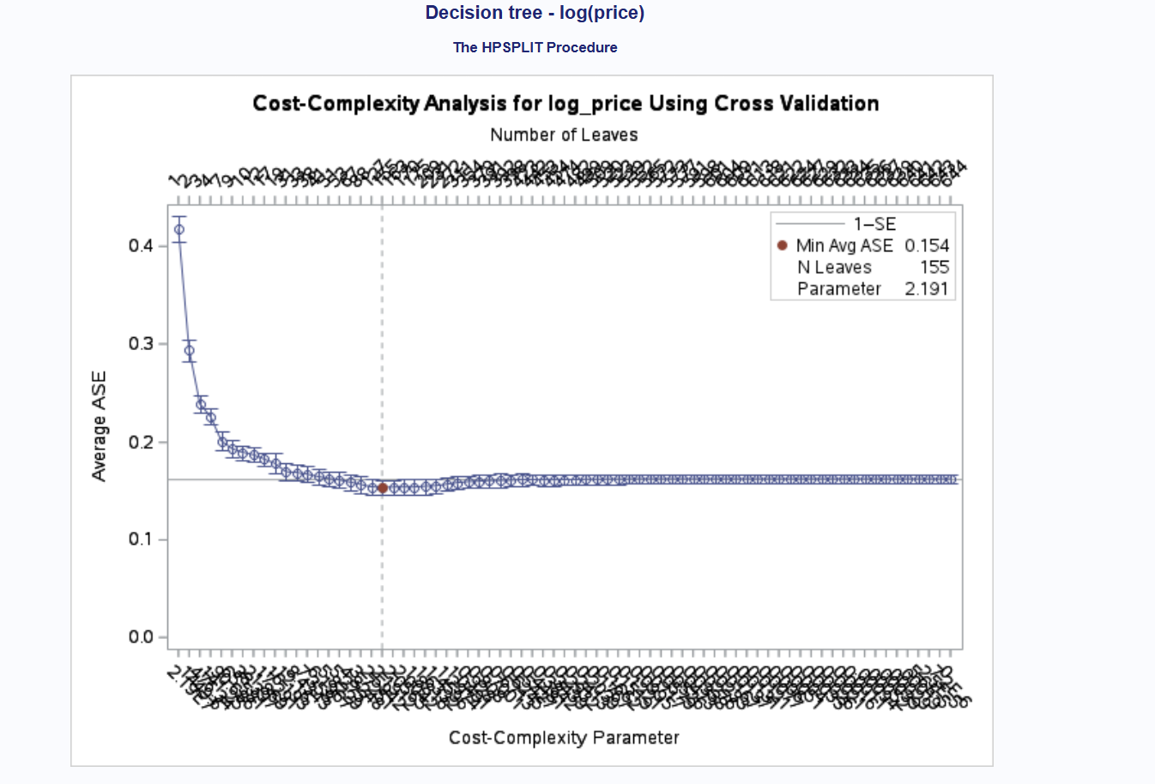

The tree structure. Figure 60 shows the whole pruned tree, and Figure 61 shows the first three levels in detail:
- First split – bedrooms: listings with fewer than 1.5 bedrooms (studios and one-bedroom units, 11,255 listings) are separated from listings with 2 or more bedrooms (6,336 listings). Size is the single most important factor in price.
- Second split – area: on both sides, the tree separates Kilimani, South-West and Westlands from CBD, East and North. This matches the LASSO results, where the first group of areas had higher prices.
- Third split: for smaller listings, the tree splits by longitude (how far east the listing is). For larger listings, it splits by accommodates (fewer than 5 guests vs 5 or more).
Figure 60: Regression Tree for log_price (overview)
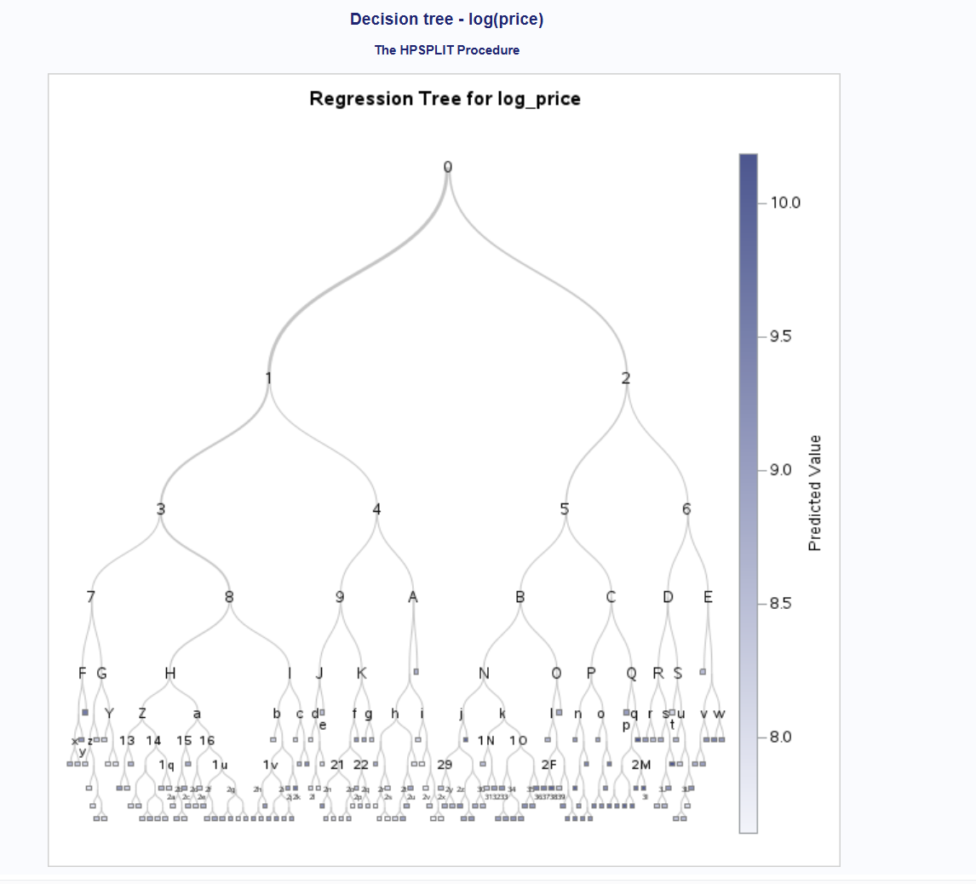

Figure 61: Subtree Starting at Node 0 (first three levels)
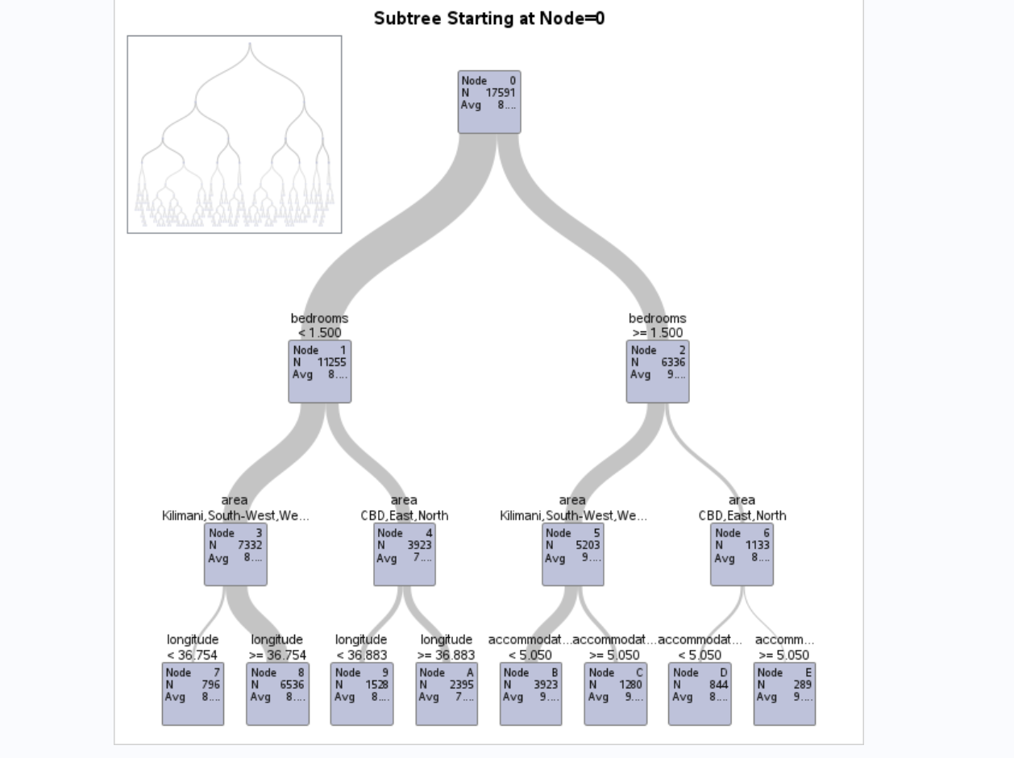
Variable importance (Figure 62). The most important predictors are bedrooms (relative importance 1.000), area (0.733), latitude (0.489), longitude (0.414) and accommodates (0.324), followed by bathrooms (0.230) and room_group (0.201). Size and location are again the main drivers of price, which agrees with the LASSO model. Availability, review counts and superhost status have very low importance (all below 0.09), and shared_bath and number_of_reviews_l30d were not used in any split.
Figure 62: Model-Based Fit Statistics and Variable Importance
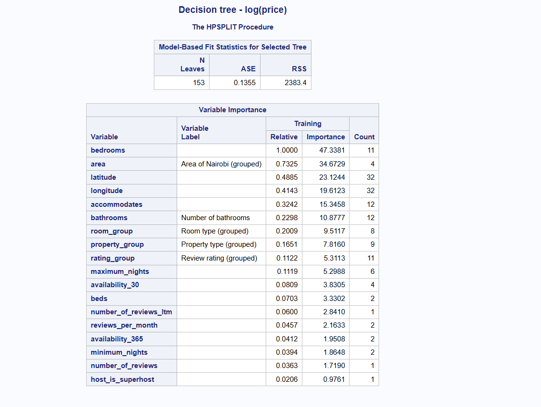

i. Scoring the Test Sample
Following Program 2.25, the CODE statement in PROC HPSPLIT saved the tree’s rules as SAS scoring code in a file (hpsplit_score.sas). I used this file in a DATA step with a %INCLUDE statement to calculate the predicted log(price) (P_log_price) for every listing in both the training and testing samples. This applies exactly the same rules from the training sample to the hold-out testing sample.
ii. RMSE and Comparison with the LASSO Regression
The decision tree’s ASE on the training data is 0.1355 (Figure 62), which gives the same RMSE as the scoring code (√0.1355 = 0.3681). Figure 63 shows the RMSE for both samples:
Sample | RMSE (log price) | RMSE (KES)
Training | 0.3681 | 3,366
Testing | 0.3973 | 3,566
Figure 63: Decision tree – RMSE for training and testing samples
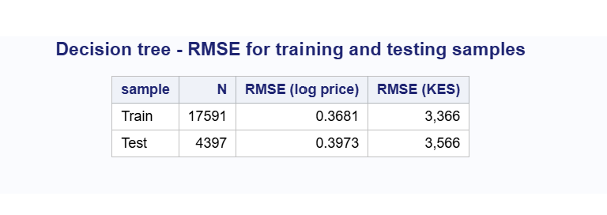
Figure 64 compares the decision tree with the LASSO regression:
Model | Sample | RMSE (log price) | RMSE (KES)
LASSO regression | Training | 0.4267 | 3,917
LASSO regression | Testing | 0.4335 | 3,882
Decision tree | Training | 0.3681 | 3,366
Decision tree | Testing | 0.3973 | 3,566
Figure 64: RMSE comparison – LASSO regression vs decision tree
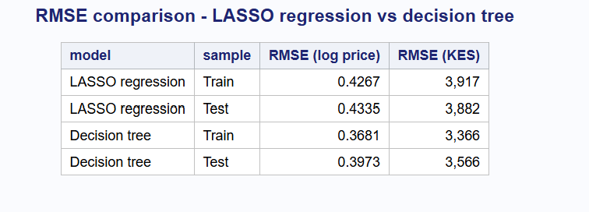

- The decision tree predicts more accurately than the LASSO regression. On the testing sample, its RMSE is 0.3973, compared with 0.4335 for LASSO, which is 8.4% lower. In Kenyan Shillings, the typical prediction error falls from about KES 3,882 to KES 3,566. The tree can capture relationships that a straight-line model misses. For example, the effect of size on price can be different in Kilimani than in the East, and the tree finds these combinations automatically.
- The decision tree overfits more than LASSO. The tree’s testing RMSE is 7.9% higher than its training RMSE (0.3973 vs 0.3681), while for LASSO the difference is only 1.6% (0.4335 vs 0.4267). The tree with 153 leaves fits some patterns in the training data that do not carry over to new listings. Even so, its testing error is still lower than LASSO’s, so it is the better predictor of the two.
- Interpretability: the LASSO model is easier to explain, because each coefficient shows how much a single factor changes price. The tree’s simple rules are easy to follow at the top levels (Figure 61), but the full tree with 153 leaves is too large to interpret as a whole.

f. Random Forest Model (PROC HPFOREST)
I fitted a random forest with PROC HPFOREST, following Program 2.26, with log_price as the target variable (LEVEL=INTERVAL). A random forest grows many decision trees and averages their predictions. Each tree is grown on a different random sample of the training listings, and at each split it may only choose from a random subset of the predictors. Because each tree sees slightly different data and predictors, the trees make different errors, and averaging them cancels out much of the overfitting that a single tree has.
The forest was trained on the training sample (17,591 listings) using the same predictors as the decision tree: 15 numeric variables (LEVEL=INTERVAL) and 5 categorical variables (LEVEL=NOMINAL). The main settings were (Figure 65):
- 200 trees (MAXTREES=200)
- 7 predictors tried at each split (VARS_TO_TRY=7), about one-third of the 20 predictors, which is a common choice for regression forests
- 60% of the training listings used to grow each tree (in-bag fraction 0.6). The remaining 40% are the out-of-bag (OOB) listings for that tree.
- a minimum of 5 listings per leaf and a maximum depth of 20
[Insert Figure 65: Random forest – Model Information and Number of Observations]
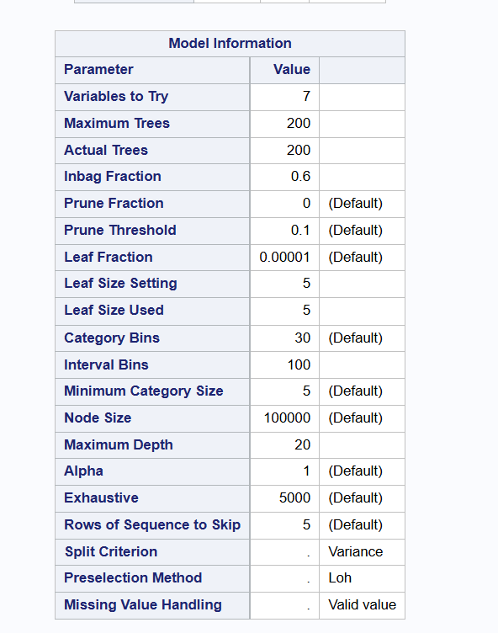
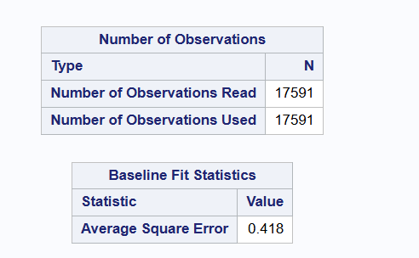

Number of trees. Table X shows how the error changes as trees are added. The baseline ASE, from predicting every listing with the overall average, is 0.418. With one tree, the OOB ASE is 0.17387. As more trees are added, the OOB error falls quickly up to about 50 trees and then levels off at about 0.133 from around 100 trees onwards. This shows that 200 trees are more than enough, and adding more would not improve the model.
Table X: Random forest fit statistics by number of trees (selected rows)
Number of trees | ASE (Train) | ASE (OOB)
1 | 0.14109 | 0.17387
10 | 0.10917 | 0.14495
25 | 0.10669 | 0.13678
50 | 0.10603 | 0.13434
100 | 0.10552 | 0.13324
150 | 0.10551 | 0.13299
200 | 0.10561 | 0.13297
Baseline ASE (no predictors) = 0.418
The OOB error is the more useful of the two columns. Each OOB listing is predicted only by trees that did not use it, so the OOB ASE is a fair estimate of how the forest will perform on new data. With 200 trees, the OOB ASE of 0.13297 corresponds to an RMSE of 0.3647 (√0.13297), very close to the RMSE on the testing sample (0.3715) reported below.
Variable importance (Figure 66). PROC HPFOREST measures importance by how much each predictor reduces the error. The OOB MSE column shows this on the out-of-bag listings. The most important predictors are bedrooms (0.05834), area (0.05834), bathrooms (0.04476), longitude (0.03799), accommodates (0.01887) and latitude (0.01688). Size and location are again the main drivers of price, as in the LASSO and decision tree models.
Several predictors have a negative OOB MSE: minimum_nights, number_of_reviews_l30d, number_of_reviews_ltm, number_of_reviews, reviews_per_month and availability_365. This means that splits on these variables did not improve predictions for new listings and added a small amount of noise. This agrees with the LASSO model, which removed most of the review count and availability variables, and with the decision tree, which gave them very low importance.
[Insert Figure 66: Loss Reduction Variable Importance]
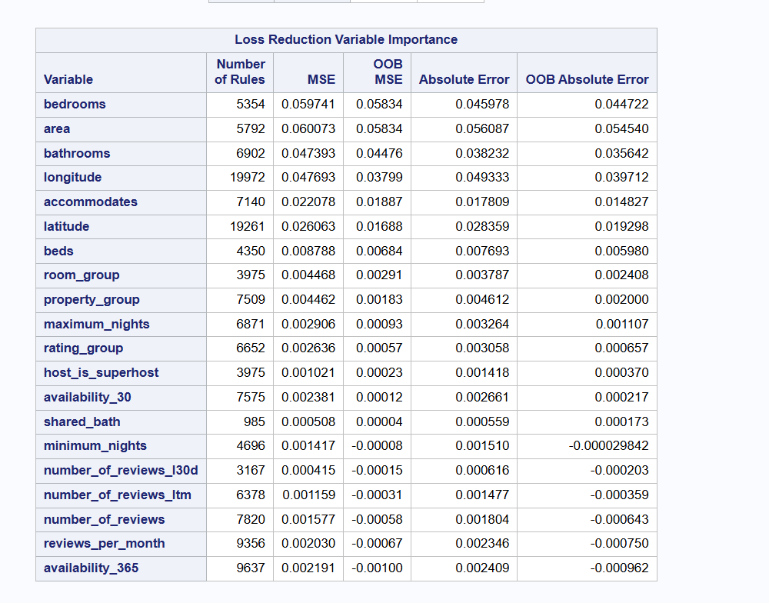

Scoring and RMSE. The SAVE statement stored the fitted forest in a file (rf_model.bin), and PROC HP4SCORE used this file to predict log(price) (P_log_price) for every listing in the training and testing samples. The RMSE values are (Figure 67):
Sample | RMSE (log price) | RMSE (KES)
Training | 0.3250 | 3,052
Testing | 0.3715 | 3,328
Insert Figure 67: Random forest – RMSE for training and testing samples
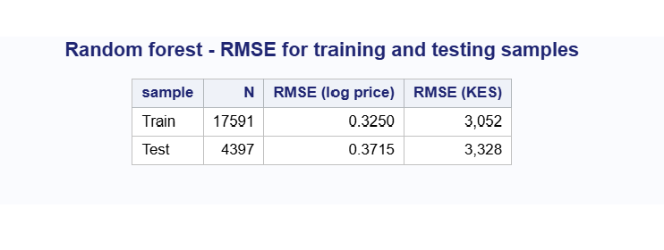

The training RMSE is lower than the testing RMSE because each training listing was used to grow some of the trees, so the forest has partly “seen” these listings. The testing RMSE (0.3715) and the OOB RMSE (0.3647) are the fair measures of performance on new data, and they agree closely.
3. Model Comparison and Recommendations
Comparing the Three Models
All three models were trained on the same training sample (17,591 listings) and tested on the same hold-out testing sample (4,397 listings), using the same predictors and log(price) as the dependent variable. This makes the comparison fair. Figure 68 shows the RMSE of each model for both samples.
[Insert Figure 68: RMSE comparison – LASSO regression, decision tree and random forest]
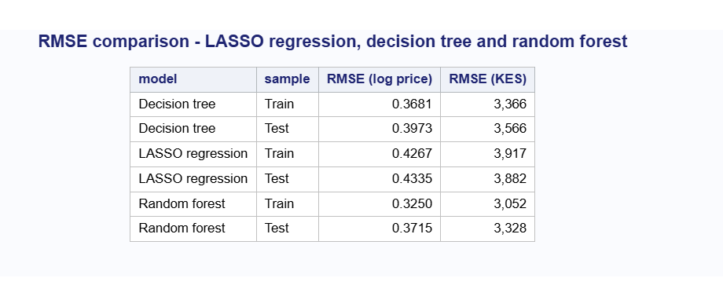

The testing sample is the main basis for comparison, because it shows how well each model predicts prices for listings it has never seen. Table 2 summarises the results:
Table 2: Summary of model performance on the testing sample
Model | Test RMSE (log price) | Test RMSE (KES) | Improvement over LASSO | Variation explained (test) | Train RMSE | Increase from train to test
LASSO regression | 0.4335 | 3,882 | – | 56% | 0.4267 | 1.6%
Decision tree | 0.3973 | 3,566 | 8.4% lower | 63% | 0.3681 | 7.9%
Random forest | 0.3715 | 3,328 | 14.3% lower | 68% | 0.3250 | 14.3% (OOB: 0.3647)
Variation explained (test) = 1 − (Test RMSE² ÷ variance of log price in the testing sample, 0.654²).
Accuracy. The random forest is the most accurate model. Its testing RMSE (0.3715) is 6.5% lower than the decision tree (0.3973) and 14.3% lower than the LASSO regression (0.4335). In Kenyan Shillings, the typical prediction error falls from about KES 3,882 (LASSO) to KES 3,566 (decision tree) to KES 3,328 (random forest). The random forest explains about 68% of the variation in log(price) for new listings, compared with 63% for the decision tree and 56% for LASSO. An RMSE of 0.3715 on the log scale means that a typical random forest prediction is within about 31% below to 45% above the actual price.
The two tree-based models predict better than LASSO because they can capture non-linear relationships and interactions without these having to be specified in advance. For example, the effect of an extra bedroom on price is different in Westlands than in the East, and a tree finds this automatically, while the linear model gives each predictor the same effect everywhere. The random forest improves on the single tree by averaging 200 trees, which reduces the errors that come from any one tree’s particular splits.
Overfitting. The LASSO model has almost no overfitting: its testing RMSE is only 1.6% higher than its training RMSE. The single decision tree overfits more (7.9%). For the random forest, the training RMSE (0.3250) is lower than the testing RMSE because each training listing was used to grow some of the trees. The more appropriate check is the out-of-bag (OOB) RMSE, which is calculated only from trees that did not use each listing. The OOB RMSE (0.3647) is very close to the testing RMSE (0.3715), which confirms that the random forest’s performance on new data is reliable.
Interpretability. The models differ in how easy they are to explain:
- LASSO regression is the easiest to interpret. Each coefficient shows how much a factor changes price, holding the others constant (for example, listings in Westlands are about 48% more expensive than in South-West). It also performs variable selection by removing weak predictors.
- The decision tree gives simple “if–then” rules at the top levels (for example, bedrooms < 1.5, then area), which are easy to explain to non-technical users. However, the full tree with 153 leaves is too large to read as a whole.
- The random forest is the hardest to interpret, because its prediction is the average of 200 trees. It can only be explained through variable importance, not through individual rules or coefficients.
Agreement between the models. All three models agree on what drives Airbnb prices in Nairobi:
- Size: bedrooms, bathrooms and accommodates are among the most important predictors in every model.
- Location: area, latitude and longitude are equally important. Westlands and Kilimani are the most expensive areas, and the East and North are the cheapest.
- Room and property type matter less, and availability, review counts, minimum nights and superhost status have little effect on price. LASSO removed most of these, and the random forest gave several of them negative OOB importance.
This agreement across three very different methods makes the findings more reliable.
Recommendations
- Use the random forest to predict prices. For a pricing tool, for example to suggest a nightly price to new hosts or to flag listings that are priced far above or below similar listings, the random forest is the best choice because it gives the most accurate predictions on new data (test RMSE 0.3715, about KES 3,328).
- Use the LASSO regression to explain prices. When the goal is to understand and communicate why prices differ, for example to tell a host how much more they could charge for an extra bedroom or a listing in a different area, the LASSO model is more useful. It is only slightly less accurate, it does not overfit, and its coefficients can be interpreted directly.
- Use the decision tree for simple guidelines. The first few splits of the decision tree (bedrooms, then area, then location or guest capacity) give clear, simple rules that can be shared with hosts who have no technical background.
- Advice for hosts. The results show that size and location set most of the price. Hosts in Westlands and Kilimani can charge the highest prices. Listings with more bedrooms and bathrooms, and entire homes rather than private rooms, earn more. Good review ratings (4.8 and above) are linked to higher prices, so maintaining guest satisfaction also supports pricing.
Limitations and Possible Improvements
- Missing information. The models explain about 56% to 68% of the variation in price. The rest depends on things not in the data, such as the quality of the interior, amenities (Wi-Fi, parking, a pool), views, security and the host’s pricing strategy. Adding amenities from the amenities column, or distance to key places such as the CBD, the airport or major shopping centres, could improve the models.
- Listed prices, not booked prices. The data shows the prices hosts ask for, not the prices guests actually paid, and it comes from a single date (14 September 2026). Prices may change with the season and with demand.
- Data cleaning choices. Removing price outliers limits the models to listings priced between KES 917 and KES 35,838. The models should not be used for luxury listings above this range. In addition, 58% of listings had no reviews, so rating information was only available for the rest.
- Model tuning. The random forest was fitted with one set of settings (200 trees, 7 predictors per split). Trying other settings, or other methods such as gradient boosting, might improve accuracy further.

